TempU08 Temperature Data Logger Manual v1.1
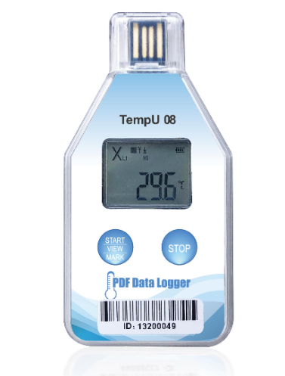
1 Product introduction
Disposable temperature data logger TempU08 is a simple portable device with LCD screen specially designed for cold chain. This product is mainly used to monitor and record the temperature data of food, medicine, chemical products and other products in the process of storage and transportation. It is widely used in all aspects of warehouse storage and logistics cold chain, such as refrigerated containers, refrigerated vehicles, refrigerated distribution boxes, refrigerated containers ,Cold storage, laboratory, etc.Data reading and parameter configuration can be realized through USB interface (which can be configured before use). After inserting, the report can be generated conveniently and automatically, and no driver needed to be installed when inserting into the computer.

2 Technical parameters

Project | Parameter
Measuring Range | -30°C ~ +60°C
Resolution | 0.1°C
Accuracy | ±0.5°C (-20°C~+40°C), ±1°C (others)
Data Capacity | 32000
Usage | Disposable
Start Mode | Button Start or Timed Start
Recording Interval | User configurable (10 seconds to 18 hours)
Start Delay | User configurable (0-254 minutes)
Alarm Range | User configurable
Alarm Type | Single type, cumulative type
Alarm Delay | User configurable (0-254 minutes)
Form of Report | PDF and CSV format data report
Interface | USB2.0 Interface
Protection Level | IP67
Product Size | 95.5mm*49mm*7.8mm
Product Weight | 25g

3 Factory default parameters of device
Project | Parameter
Temperature Unit | ℃
Temperature Alarm Limit | < 2 ℃ or > 8 ℃
Alarm Delay | 10 minutes
Recording Interval | 10 minutes
Start Delay | 30 minutes
Equipment Time | UTC time
LCD Display Time | 1minute
Start Mode | Press button to start

4 Operating Instructions
1）Start recording
Long press the start button for more than 3ss until the screen“▶”or the "wait" symbol is on, indicating that the device has successfully started recording.
2）Marking
When the device is in the recording state, long press the start button for more than 3s, and the screen will jump to "mark" interface, mark number plus one, indicating successful marking.
3）Stop recording
Long press the stop button for more than 3suntil the "■" symbol on the screen lights up, indicating that the device stops recording.

5 LCD display description
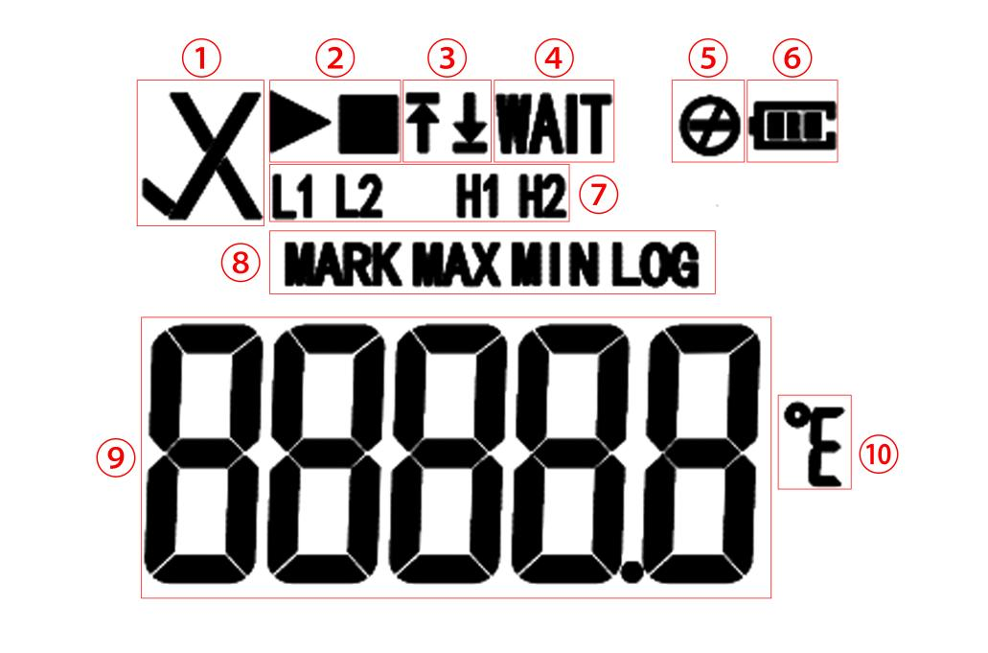
1 | √Normal  ×Alarm | 6 | Battery Power
2 | ▶ In recording status  ■ Stop recording status | 8 | Interface indication
3And 7 | Alarm area:  ↑ H1 H2 (high temperature alarm)  ↓ L1 L2 (low temperature alarm) | 9 | Temperature value
4 | Start delay status | 10 | Temperature unit
5 | Button Stop Mode invalid

1） Short press the start button to switch the display interface in turn
Real time temperature interface → Data number interface → Mark number interface → Temperature maximum interface →Temperature minimum interface.

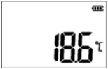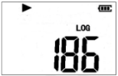
① Real time temperature interface
(initialization state) ② Log interface (record state)

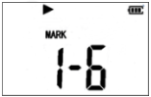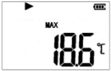
③ Mark number interface
(record state) ④ Temperature max interface (record state)

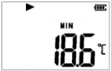

⑤ Temperature minimum interface (record state)

6 Description of battery status display

Power Display | Capacity
 | 40％～100％
 | 15％～40％
 | 5％～15％
 | ＜5％

Notice：
The battery indication status can not accurately represent the battery power in different low temperature environment.

7 Computer operation
Insert the device into the computer and wait until the PDF and CSV reports are generated. The computer will display the U disk of the device and click to view the report.

