Beacon Settings
1：Choose the device model——EV-206M
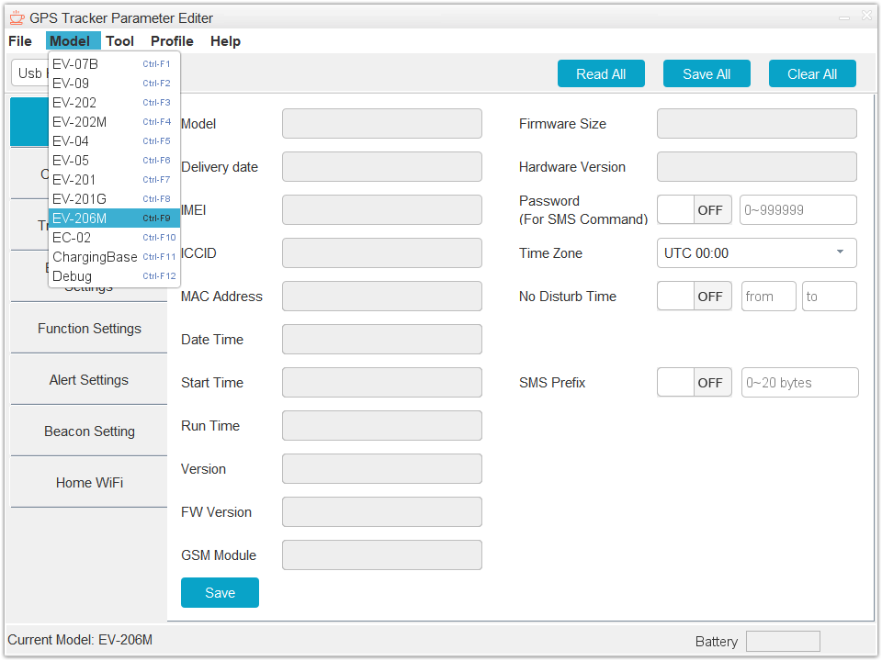
2：Click the “Read ALL” button for read device data
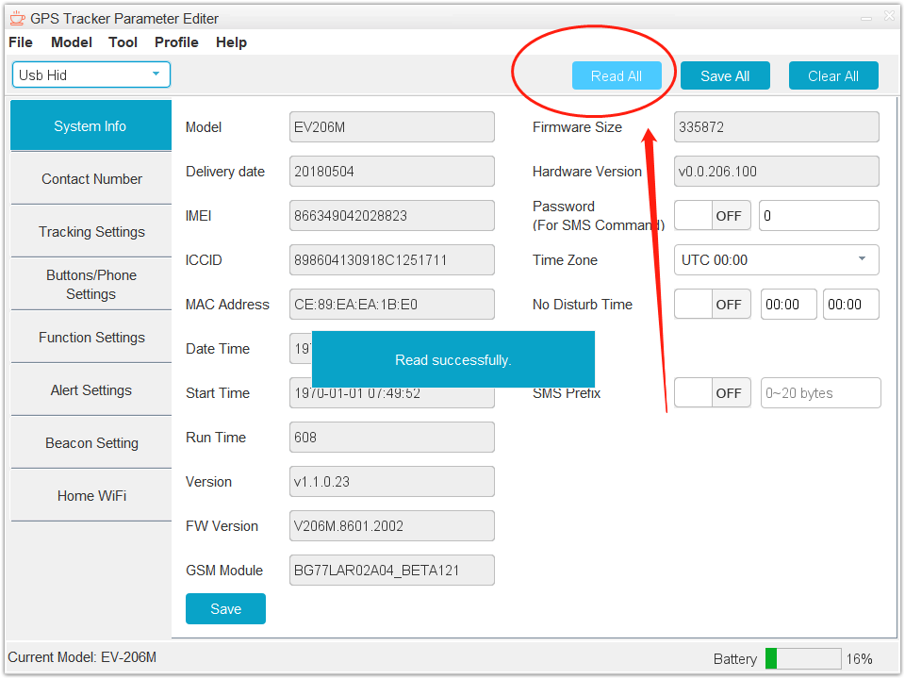
3：Turn to page “Beacon Settings” and click the “scan” button。Wait 15s
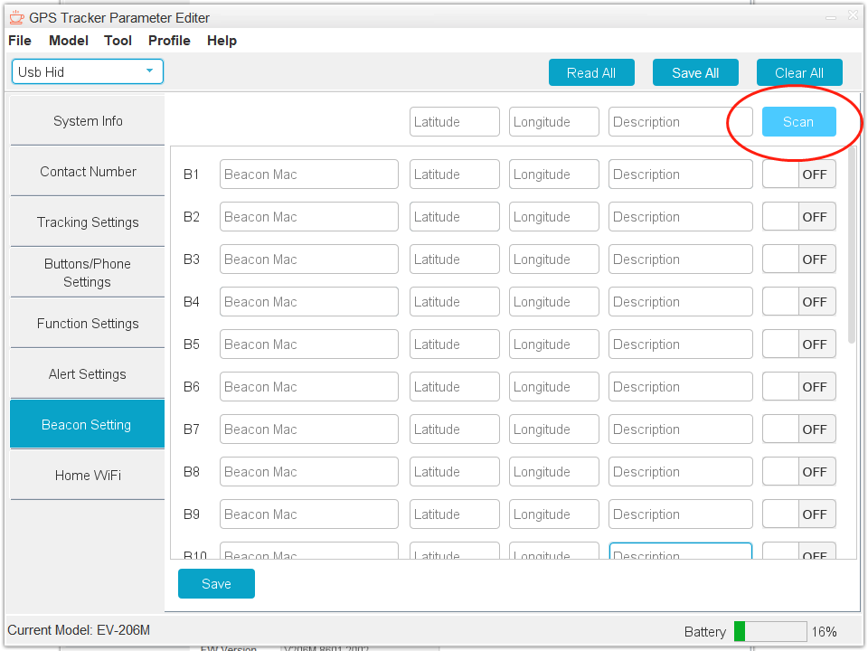

4：Click "Read All" again after 15s

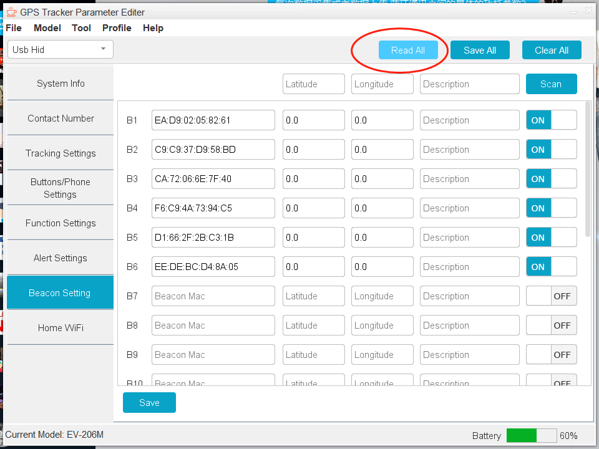
5：Choose the MAC Address corresponding to the charging base MAC, then “ON”。（The MAC Address label is pasted under the charging base）

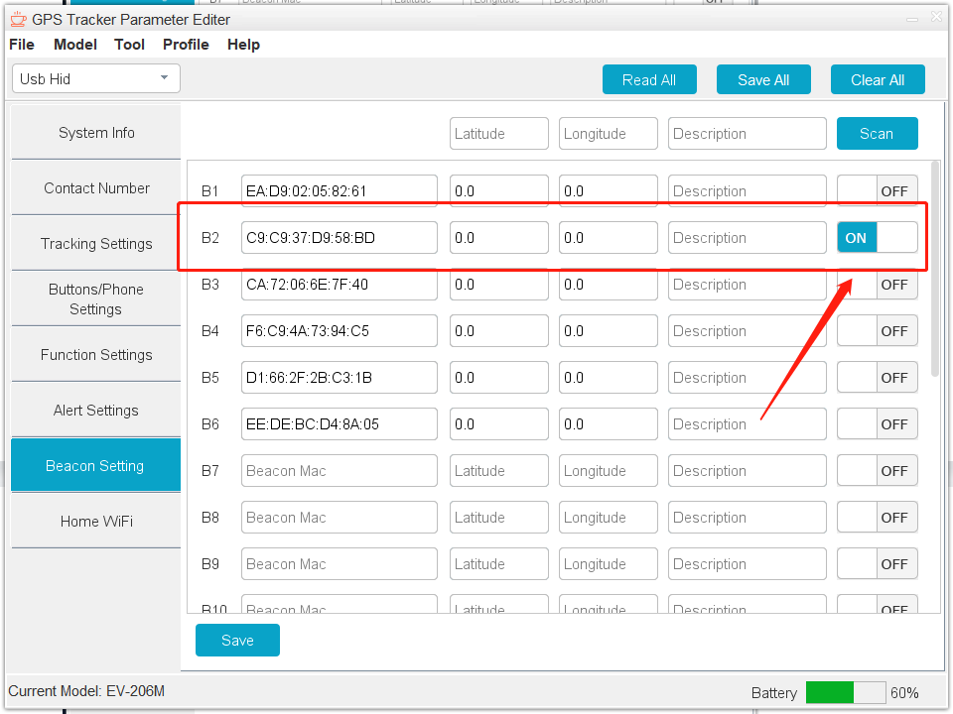

6：Save all settings

Home WIFI Settings
1：Turn to page “Home WIFI Settings” and click the “scan” button

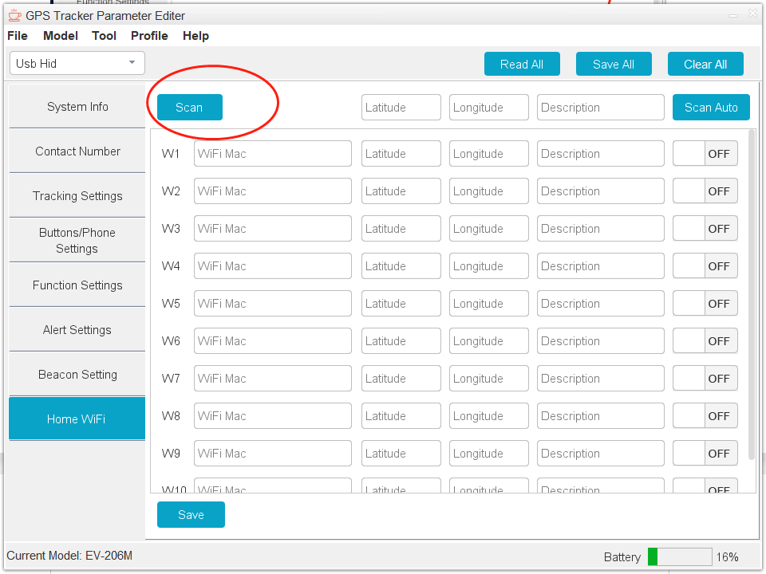
2：Follow the order in the picture——1、“Scan” the MAC Address。2、Choose your need MAC。3、“Add” the MAC
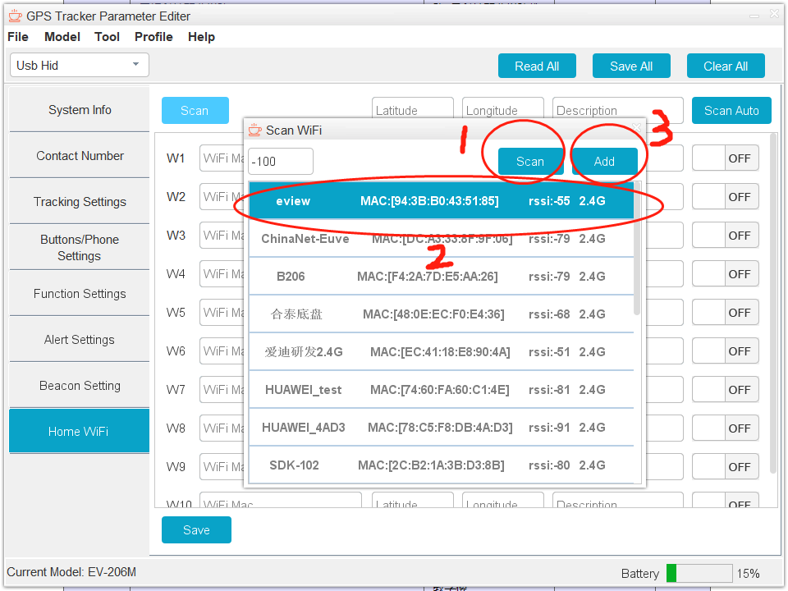
3：Set the added mac address to "ON"
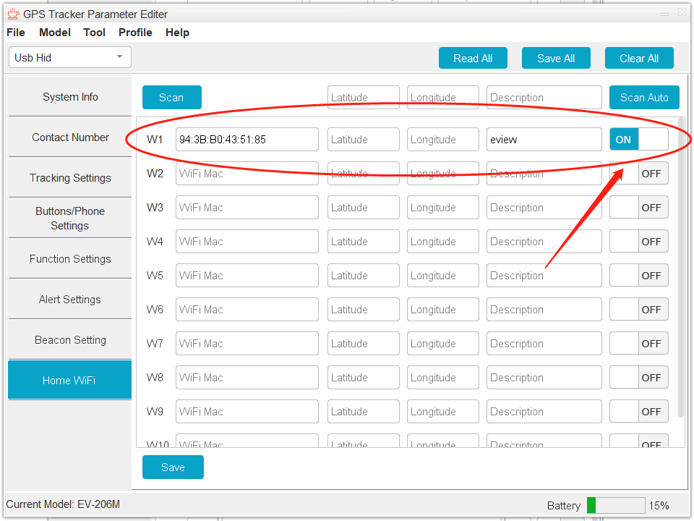

4：Save all settings

