PRODUCT SPECIFICATION

MIPI 5M

Camera Module

SNS51734-V1.0

Supplier confirmation
Department | Engineer | Quality inspector | Approver
Name / signature | [LI] | [Name / signature] | [Name / signature]
Date | [26-10-24] | [YYYY-MM-DD] | [YYYY-MM-DD]

Customer confirmation
Department | Structure / appearance | Electronics | Approver
Name / signature | [Name / signature] | [Name / signature] | [Name / signature]
Date | [YYYY-MM-DD] | [YYYY-MM-DD] | [YYYY-MM-DD]

Contact information
SHENZHEN SINOSEEN TECHNOLOGY


2nd Floor, Building C, Innovation Silicon Valley Industrial Park, Jingtian Road, Guanlan Guanhu Street, Longhua District, Shenzhen, China

https://www.sinoseen.com/



Revision History
Date | Version | Revision Details
2024-08-15 | V1.0 | The First Version

Product Overview

Product Introduction
SNS51734-V1.0 is a compact camera module using the AR0521 5MP CMOS image sensor. Featuring OmniBSI+ technology, the sensor outputs RAW images at 2592 × 1944. Image quality, data transfer and camera functions are controlled through the SCCB interface. The sensor supports up to 60 fps at full resolution.

Applications
- Barcode scanners: Used for home surveillance, video doorbells and smart locks.
- 3D scanning and QR code scanning
- Face, gesture and iris recognition
- Industrial inspection, AR/VR headsets and pattern inspection
- Pattern inspection
- High-speed image capture

Product Specifications
Item | Specification | Item | Specification
Model | SNS51734-V1.0 | Image Sensor | AR0521
Resolution | 2592 × 1944 (5MP) | Optical Format | 1/2.5-inch CMOS
Pixel Size | 2.2 μm × 2.2 μm | Shutter Type | Rolling shutter
Output Format | 8-bit / 10-bit RGB RAW | Dynamic Range | 67 dB (8× gain)
Sensitivity | 600 mV/(lux·s) | Maximum SNR | 34 dB
Dark Current | 8 mV/s (50°C junction) | Chief Ray Angle | 29.1°
AVDD (drawing) | 2.7 V | DOVDD (drawing) | 1.8 V
DVDD (drawing) | 1.2 V | Control Interface | SCCB
Standby Power | 35 µW | Active Power | 198 mW
Stable Image Junction Temp. | 0°C to 50°C | Operating Junction Temp. | −30°C to 70°C
Connector | 28PIN/0.5MM/2.0H | Input Clock | 6–27 MHz

Lens Specifications
Item | Specification | Item | Specification
Effective Focal Length | 6.0 mm ±5% | F-number | 2.4 ±5%
Diagonal FOV | 61° ±3° | Lens Construction | 2G2P + IR
Distortion (drawing) | <1% | IR Filter | 650 nm

Maximum Sensor Frame Rates
Mode | Resolution | Maximum Frame Rate
QSXGA | 2592 × 1944 | 60 fps
1080p | 1920 × 1080 | 60 fps
960p | 960p mode | 60 fps
720p | 1280 × 720 | 60 fps
VGA | 640 × 480 | 60 fps
These are sensor-level specifications. Junction temperatures and sensor power consumption do not represent the module’s rated ambient temperature or total system power consumption. Available frame rates depend on the module configuration and host system.

Mechanical Specifications
Item | Specification | Item | Specification
FPC Thickness | 0.12 ±0.2 mm | Steel Stiffener | 0.3 ±0.05 mm
Overall Length | 171.5 ±0.2 mm | Overall Width | 30.0 ±0.2 mm
Overall Height | 11.4 ±0.2 mm | Base Dimensions | 30.0 × 18.0 mm (±0.2 mm)

Product structural drawing

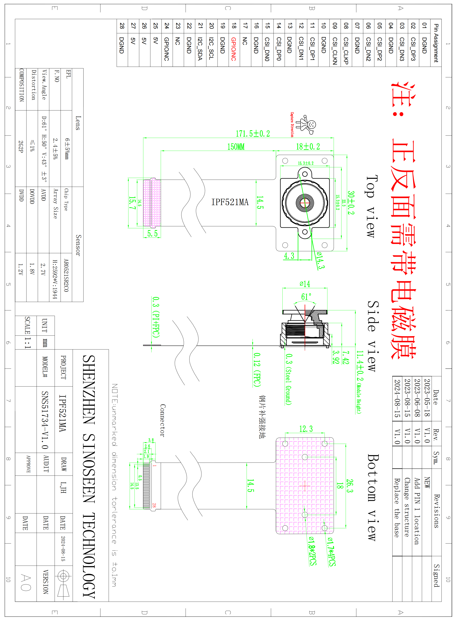

Connector Pin Assignment
Pin No. | Signal | I/O | Description | Remarks
1 | DGND | Ground | Ground
2 | CSI_ DP3 | Output | MIPI data 3 positive electrode signal
3 | CSI_ DN3 | Output | MIPI data 3 negative electrode signal
4 | DGND | Ground | Ground
5 | CSI_DP2 | Output | MIPI data 2 positive electrode signal
6 | CSI_DN2 | Output | MIPI data 2 negative electrode signal
7 | DGND | Ground | Ground
8 | CSI_CLKP | Output | MIPI clock positive eleetrode signal
9 | CSI_CLKN | Output | MIPI clock negative electrode signal
10 | DGND | Ground | Ground
11 | CSI_DP1 | Output | MIPI data 1 positive electrode signal
12 | CSI_DN1 | Output | MIPI data 1 negative electrode signal
13 | DGND | Ground | Ground
14 | CSI_DP0 | Output | MIPI data 0 positive electrode signal
15 | CSI_DN0 | Output | MIPI data 0 negative electrode signal
16 | DGND | Ground | Ground
17 | NC | NC | NC
18 | GPIO/NC | NC | NC
19 | DGND | Ground | Ground
20 | I2C_SCL | Input | SCCB serial interface clock input
21 | I2C_SDA | I/O | SCCB serial interface data IO
22 | DGND | Ground | Ground
23 | NC | NC | NC
24 | GPIO/NC | NC | NC
25 | 5V | Power | I/O power supply
26 | 5V | Power | I/O power supply
27 | 5V | Power | I/O power supply
28 | DGND | Ground | Ground
29
30

