PRODUCT SPECIFICATION

MIPI 13M

Camera Module

XLS131796-V1.0

Supplier confirmation
Department | Engineer | Quality inspector | Approver
Name / signature | [LI] | [Name / signature] | [Name / signature]
Date | [26-10-30] | [YYYY-MM-DD] | [YYYY-MM-DD]

Customer confirmation
Department | Structure / appearance | Electronics | Approver
Name / signature | [Name / signature] | [Name / signature] | [Name / signature]
Date | [YYYY-MM-DD] | [YYYY-MM-DD] | [YYYY-MM-DD]

Contact information
SHENZHEN SINOSEEN TECHNOLOGY


2nd Floor, Building C, Innovation Silicon Valley Industrial Park, Jingtian Road, Guanlan Guanhu Street, Longhua District, Shenzhen, China

https://www.sinoseen.com/



Revision History
Date | Version | Revision Details
2023-09-09 | V1.0 | The First Version

Product Overview

Product Introduction
XLS131796-V1.0 is a compact camera module using the S5K3L8 13MP CMOS image sensor. Featuring OmniBSI+ technology, the sensor outputs RAW images at 4208 × 3120. Image quality, data transfer and camera functions are controlled through the SCCB interface. The sensor supports up to 240 fps at full resolution.

Applications
- Barcode scanners: Used for home surveillance, video doorbells and smart locks.
- 3D scanning and QR code scanning
- Face, gesture and iris recognition
- Industrial inspection, AR/VR headsets and pattern inspection
- Pattern inspection
- High-speed image capture

Product Specifications
Item | Specification | Item | Specification
Model | XLS131796-V1.0 | Image Sensor | S5K3L8
Resolution | 4208 × 3120 (13MP) | Optical Format | 1/3.06-inch CMOS
Pixel Size | 1.12 μm × 1.12 μm | Shutter Type | Rolling shutter
Output Format | 8-bit / 10-bit RGB RAW | Dynamic Range | 67 dB (8× gain)
Sensitivity | 600 mV/(lux·s) | Maximum SNR | 34 dB
Dark Current | 8 mV/s (50°C junction) | Chief Ray Angle | 29.1°
AVDD (drawing) | 2.8 V | DOVDD (drawing) | 1.8 V
DVDD (drawing) | 1.2 V | Control Interface | SCCB
Standby Power | 35 µW | Active Power | 198 mW
Stable Image Junction Temp. | 0°C to 50°C | Operating Junction Temp. | −30°C to 70°C
Connector | OK-118RM024/2-35 | Input Clock | 6–27 MHz

Lens Specifications
Item | Specification | Item | Specification
Effective Focal Length | 3.54 mm ±5% | F-number | 2.0 ±5%
Diagonal FOV | 78° ±3° | Lens Construction | 5P + IR
Distortion (drawing) | <1% | IR Filter | 650 nm

Maximum Sensor Frame Rates
Mode | Resolution | Maximum Frame Rate
QSXGA | 2592 × 1944 | 30 fps
1080p | 1920 × 1080 | 60 fps
960p | 960p mode | 120 fps
720p | 1280 × 720 | 120 fps
VGA | 640 × 480 | 240 fps
These are sensor-level specifications. Junction temperatures and sensor power consumption do not represent the module’s rated ambient temperature or total system power consumption. Available frame rates depend on the module configuration and host system.

Mechanical Specifications
Item | Specification | Item | Specification
FPC Thickness | 0.15 ±0.05 mm | Shteel Stiffener | 0.2 ±0.05 mm
Overall Length | 17.55 ±0.2 mm | Overall Width | 10.8 ±0.2 mm
Overall Height | 6.2 ±0.2 mm | Base Dimensions | 8.5 × 8.5 mm (±0.2 mm)

Product structural drawing

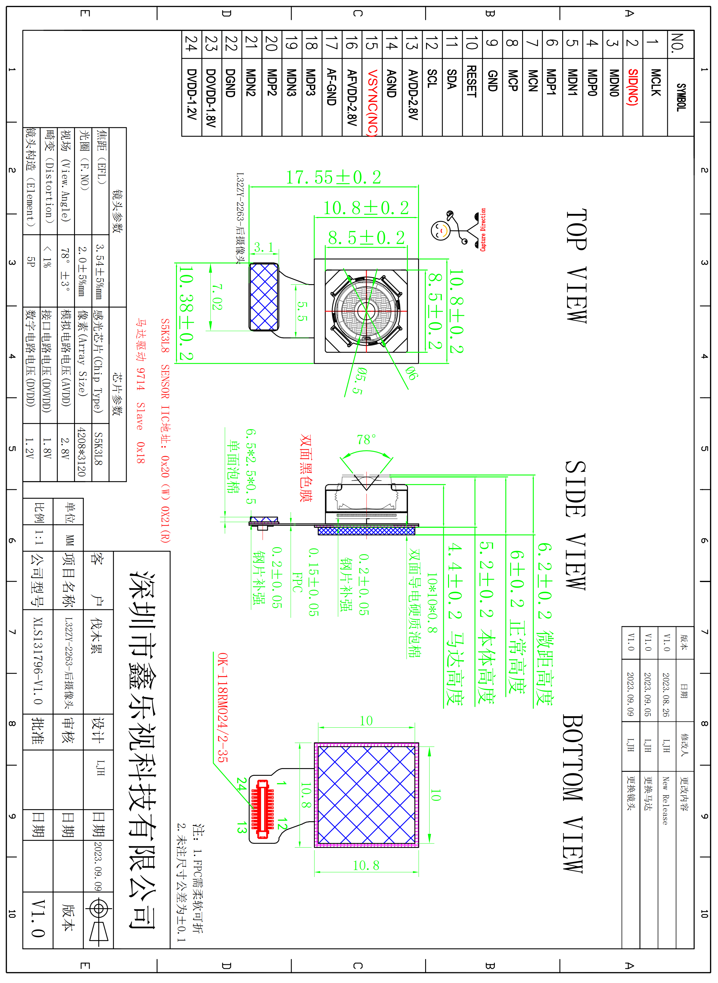

Connector Pin Assignment
Pin No. | Signal | I/O | Description | Remarks
1 | MCLK | input | Clock input
2 | SID(NC) | NC | NC
3 | MDN0 | Output | MIPI data 0 negative electrode signal
4 | MDP0 | Output | MIPI data 0 positive electrode signal
5 | MDN1 | Output | MIPI data 1 negative electrode signal
6 | MDP1 | Output | MIPI data 1 positive electrode signal
7 | MCN | Output | MIPI clock negative electrode signal
8 | MCP | Output | MIPI clock positive eleetrode signal
9 | GND | Ground | Ground
10 | RESET | Input | Reset signal input (built-up resistance, low potential)
11 | SDA | I/O | SCCB serial interface data IO
12 | SCL | Input | SCCB serial interface clock input
13 | AVDD-2.8V | Power | Analog power supply
14 | AGND | Ground | Ground
15 | VSYNC(NC) | NC | NC
16 | AFVDD-2.8V | Power | AF power supply
17 | AF-GND | Ground | Ground
18 | MDP3 | Output | MIPI data 3 positive electrode signal
19 | MDN3 | Output | MIPI data 3 negative electrode signal
20 | MDP2 | Output | MIPI data 2 positive electrode signal
21 | MDN2 | Output | MIPI data 2 negative electrode signal
22 | DGND | Ground | Ground
23 | DOVDD-1.8V | Power | I/O power supply
24 | DVDD-1.2V | Power | Digital power supply
25
26
27
28
29
30

