
PRODUCT SPECIFICATION

USB 1080P

Camera Module

XLS-USB291-V1.0

Supplier confirmation
Department | Engineer | Quality inspector | Approver
Name / signature | [LI] | [Name / signature] | [Name / signature]
Date | [26-10-31] | [YYYY-MM-DD] | [YYYY-MM-DD]

Customer confirmation
Department | Structure / appearance | Electronics | Approver
Name / signature | [Name / signature] | [Name / signature] | [Name / signature]
Date | [YYYY-MM-DD] | [YYYY-MM-DD] | [YYYY-MM-DD]

Contact information
SHENZHEN SINOSEEN TECHNOLOGY


2nd Floor, Building C, Innovation Silicon Valley Industrial Park, Jingtian Road, Guanlan Guanhu Street, Longhua District, Shenzhen, China

https://www.sinoseen.com/


Revision History
Date | Version | Revision Details
2023-10-31 | V1.0 | The First Version

Product overview

Product Introduction
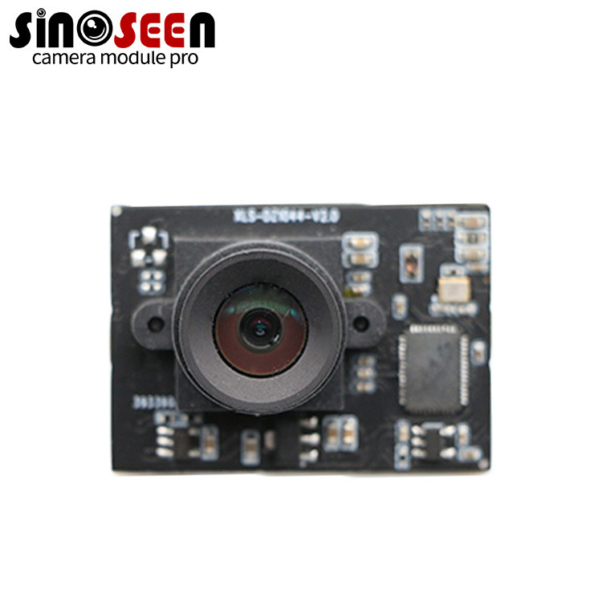 | XLS-USB291-V1.0 is an 1080P Ultra HD auto focus or fixed focus camera module .The maximum resolutionis 1920*1080 .Support up to 1080P/30 frame high-definition picture output .The  module supports USB2.0 interface,no need to install driver.The finished camera module hasthe characteristics of small size,accurate color reproduction,clear image,low power consumption andhigh reliability.

Applications
- Video conferencing
- Security and smart home
- Document cameras
- Industrial inspection
- Identity recognition
- ATMs
- Access control equipment

Product details
Item | Specification | Item | Specification
Model | XLS-USB291-V1.0 | Interface | 5-pin, 1.25 mm pitch, USB 2.0
Video output | MJPG, YUY2 | USB signaling rate | 260 Mb/s
Supply voltage | 5 V ±5% | Microphone | Dual digital noise-reduction microphone
Operating temperature | 0°C to 50°C | Storage temperature | −25°C to 70°C
Power consumption | No LED: / | IR LED | /
OS support | Windows XP / Vista / 7 / 8 / 8.1 / 10 | Other OS support | Mac / Android / Linux 2.6.2 (UVC) / WinCE

Chip parameters
Item | Specification | Item | Specification
Sensor format | 1/2.8-inch CMOS | Effective pixels | 1920 × 1080
Pixel size | 3.0 µm × 3.0 µm | Sensor data output | 10-bit RAW
Maximum SNR | TBD | Dynamic range | TBD
Minimum illumination | TBD (no LED) | Optical distortion | <4%

Lens parameters
Item | Specification | Item | Specification
Lens mount | M12 × P0.25 | Construction | 4G
F-number | 1.8 ±5% | Effective focal length | 8.0 mm
Field of view | Diagonal: 41° ±3° | Focus distance | 60 cm to infinity

Maximum frame rate
Format | Resolution | Maximum frame rate
MJPG | 1920x1200 1920x1080 1600x1200 1280x1024 1024x1024 1280x960 1280x720 1024x768 960x720 800x600 640x480 320x240 | 30 fps

Product structural drawing
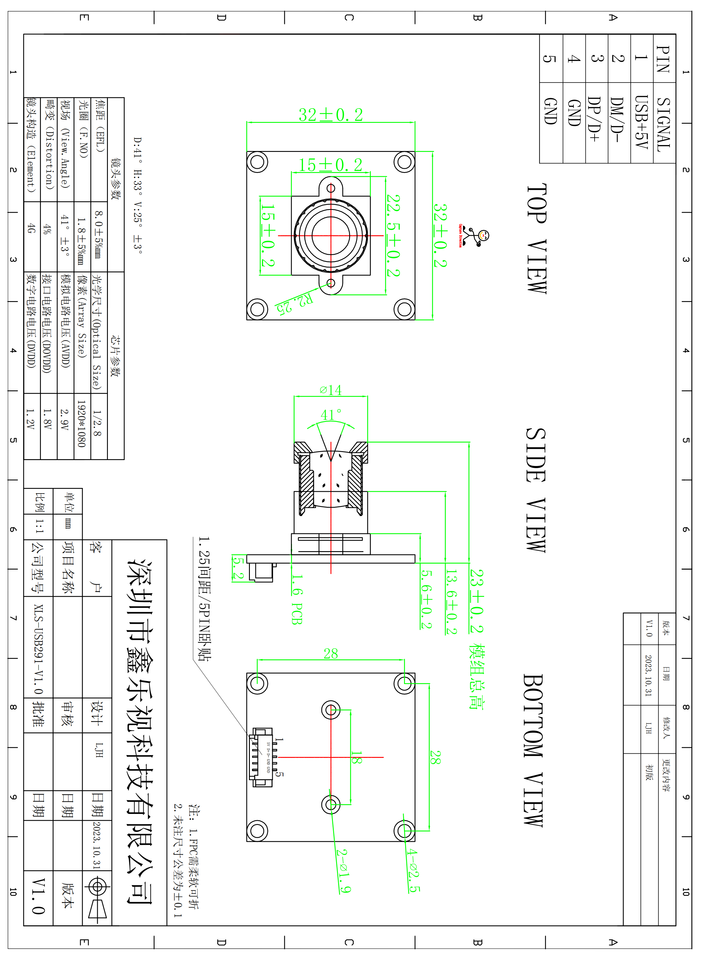

USB connector pin assignment
Pin NO | Pin Name | I/O | Description | Remarks
1 | VCC 5V | P | +5V power supply
2 | D- | A | USB data cable-
3 | D+ | A | USB data cable+
4 | GND | G | Ground
5 | GND | G | Ground

