PRODUCT SPECIFICATION

MIPI 13M

Camera Module

SNS131710-V1.0

Supplier confirmation
Department | Engineer | Quality inspector | Approver
Name / signature | [LI] | [Name / signature] | [Name / signature]
Date | [26-10-31] | [YYYY-MM-DD] | [YYYY-MM-DD]

Customer confirmation
Department | Structure / appearance | Electronics | Approver
Name / signature | [Name / signature] | [Name / signature] | [Name / signature]
Date | [YYYY-MM-DD] | [YYYY-MM-DD] | [YYYY-MM-DD]

Contact information
SHENZHEN SINOSEEN TECHNOLOGY


2nd Floor, Building C, Innovation Silicon Valley Industrial Park, Jingtian Road, Guanlan Guanhu Street, Longhua District, Shenzhen, China

https://www.sinoseen.com/



Revision History
Date | Version | Revision Details
2023-04-26 | V1.0 | The First Version

Product Overview

Product Introduction
SNS131710-V1.0 is a compact camera module using the OV13850 13MP CMOS image sensor. Featuring OmniBSI+ technology, the sensor outputs RAW images at 4224 × 3136. Image quality, data transfer and camera functions are controlled through the SCCB interface. The sensor supports up to 60 fps at full resolution.

Applications
- Barcode scanners: Used for home surveillance, video doorbells and smart locks.
- 3D scanning and QR code scanning
- Face, gesture and iris recognition
- Industrial inspection, AR/VR headsets and pattern inspection
- Pattern inspection
- High-speed image capture

Product Specifications
Item | Specification | Item | Specification
Model | SNS131710-V1.0 | Image Sensor | OV13850
Resolution | 4224 × 3136 (13MP) | Optical Format | 1/3.06-inch CMOS
Pixel Size | 1.12 μm × 1.12 μm | Shutter Type | Rolling shutter
Output Format | 8-bit / 10-bit RGB RAW | Dynamic Range | 67 dB (8× gain)
Sensitivity | 600 mV/(lux·s) | Maximum SNR | 34 dB
Dark Current | 8 mV/s (50°C junction) | Chief Ray Angle | 29.1°
AVDD (drawing) | 2.8 V | DOVDD (drawing) | 1.8 V
DVDD (drawing) | 1.2 V | Control Interface | SCCB
Standby Power | 35 µW | Active Power | 198 mW
Stable Image Junction Temp. | 0°C to 50°C | Operating Junction Temp. | −30°C to 70°C
Connector | 30PIN/0.5MM/drawer type/bedside patch/2.0H | Input Clock | 6–27 MHz

Lens Specifications
Item | Specification | Item | Specification
Effective Focal Length | 3.37 mm ±5% | F-number | 2.2 ±5%
Diagonal FOV | 81° ±3° | Lens Construction | 5P + IR
Distortion (drawing) | <1% | IR Filter | 650 nm

Maximum Sensor Frame Rates
Mode | Resolution | Maximum Frame Rate
QSXGA | 2592 × 1944 | 30 fps
1080p | 1920 × 1080 | 60 fps
960p | 960p mode | 60 fps
720p | 1280 × 720 | 60 fps
VGA | 640 × 480 | 60 fps
These are sensor-level specifications. Junction temperatures and sensor power consumption do not represent the module’s rated ambient temperature or total system power consumption. Available frame rates depend on the module configuration and host system.

Mechanical Specifications
Item | Specification | Item | Specification
FPC Thickness | 0.12 ±0.05 mm | Steel sheet | 0.2 ±0.05 mm
PCB Thickness | 1.6mm | / | /
Overall Length | 33.7 ±0.2 mm | Overall Width | 25.0 ±0.2 mm
Overall Height | 5.02 ±0.2 mm | Base Dimensions | 8.5 × 8.5 mm (±0.2 mm)

Product structural drawing

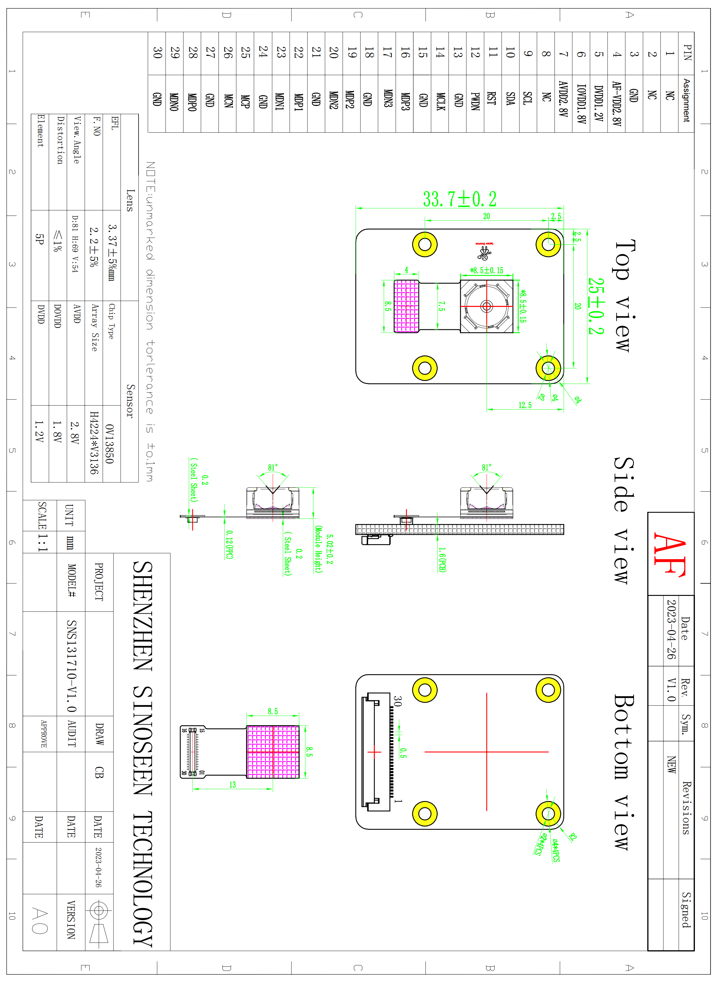

Connector Pin Assignment
Pin No. | Signal | I/O | Description | Remarks
1 | NC | NC | NC
2 | NC | NC | NC
3 | GND | Ground | Ground
4 | AF-VDD2.8V | Power | AF power supply
5 | DVDD1.2V | Power | Digital power supply
6 | IOVDD1.8V | Power | I/O power supply
7 | AVDD2.8V | Power | Analog power supply
8 | NC | NC | NC
9 | SCL | Input | SCCB serial interface clock input
10 | SDA | I/O | SCCB serial interface data IO
11 | RST | Input | Reset signal input (built-up resistance, low potential)
12 | PWDN | Input | power down（active high with internal pull-down resistor)
13 | GND | Ground | Ground
14 | MCLK | input | Clock input
15 | GND | Ground | Ground
16 | MDP3 | Output | MIPI data 3 positive electrode signal
17 | MDN3 | Output | MIPI data 3 negative electrode signal
18 | GND | Ground | Ground
19 | MDP2 | Output | MIPI data 2 positive electrode signal
20 | MDN2 | Output | MIPI data 2 negative electrode signal
21 | GND | Ground | Ground
22 | MDP1 | Output | MIPI data 1 positive electrode signal
23 | MDN1 | Output | MIPI data 1 negative electrode signal
24 | GND | Ground | Ground
25 | MCP | Output | MIPI clock positive eleetrode signal
26 | MCN | Output | MIPI clock negative electrode signal
27 | GND | Ground | Ground
28 | MDP0 | Output | MIPI data 0 positive electrode signal
29 | MDN0 | Output | MIPI data 0 negative electrode signal
30 | GND | Ground | Ground

