PRODUCT SPECIFICATION

MIPI 5M

Camera Module

XLS58875-V1.1

Supplier confirmation
Department | Engineer | Quality inspector | Approver
Name / signature | [LI] | [Name / signature] | [Name / signature]
Date | [26-10-24] | [YYYY-MM-DD] | [YYYY-MM-DD]

Customer confirmation
Department | Structure / appearance | Electronics | Approver
Name / signature | [Name / signature] | [Name / signature] | [Name / signature]
Date | [YYYY-MM-DD] | [YYYY-MM-DD] | [YYYY-MM-DD]

Contact information
SHENZHEN SINOSEEN TECHNOLOGY


2nd Floor, Building C, Innovation Silicon Valley Industrial Park, Jingtian Road, Guanlan Guanhu Street, Longhua District, Shenzhen, China

https://www.sinoseen.com/



Revision History
Date | Version | Revision Details
2018-07-23 | V1.1 | The First Version

Product Overview

Product Introduction
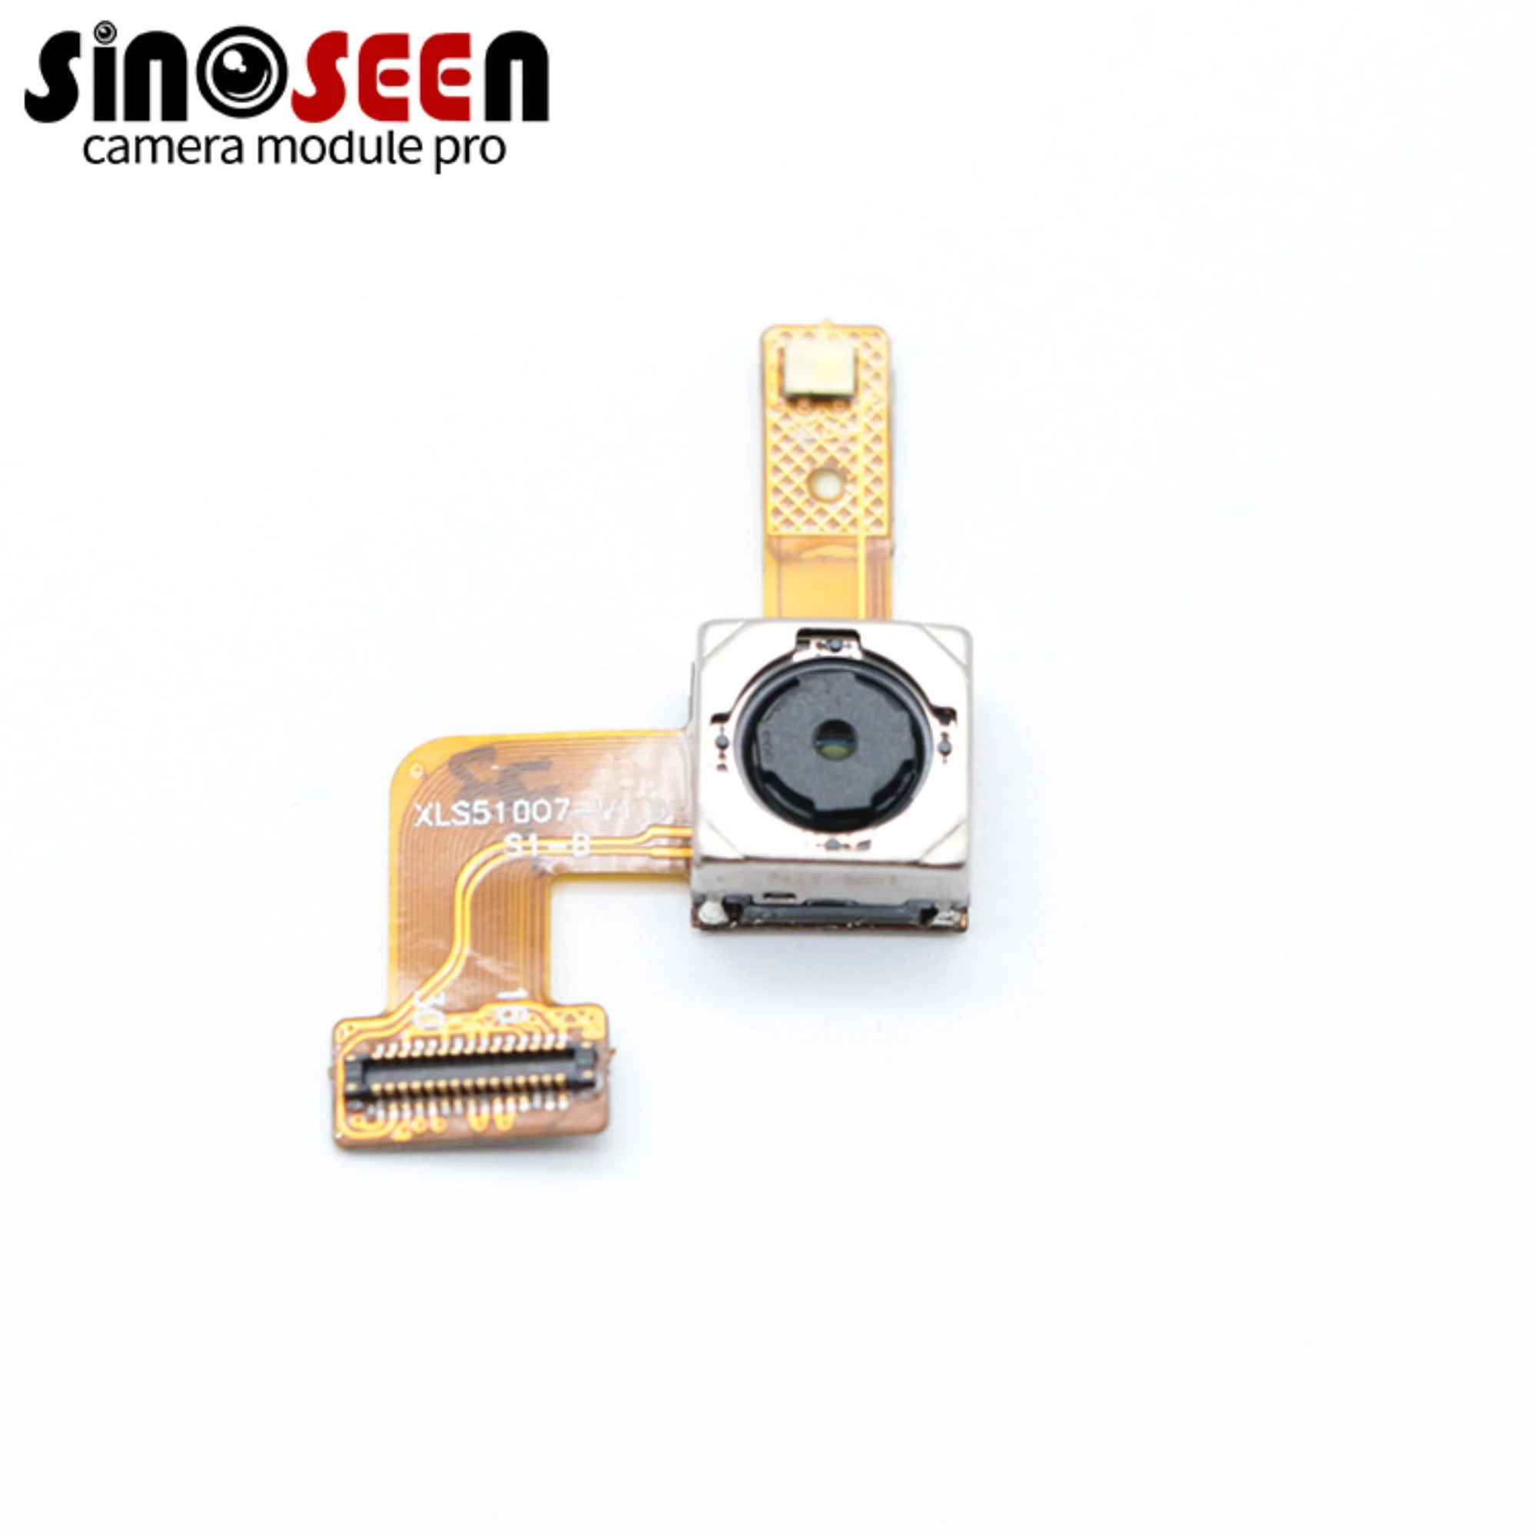 | XLS58875-V1.1 is a compact camera module using the OV5648 5MP CMOS image sensor. Featuring OmniBSI+ technology, the sensor outputs RAW images at 2592 × 1944. Image quality, data transfer and camera functions are controlled through the SCCB interface. The sensor supports up to 90 fps at full resolution.

Applications
- Barcode scanners: Used for home surveillance, video doorbells and smart locks.
- 3D scanning and QR code scanning
- Face, gesture and iris recognition
- Industrial inspection, AR/VR headsets and pattern inspection
- Pattern inspection
- High-speed image capture

Product Specifications
Item | Specification | Item | Specification
Model | SNS58875-V1.1 | Image Sensor | OV5648
Resolution | 2592 × 1944 (5MP) | Optical Format | 1/4-inch CMOS
Pixel Size | 1.14 μm × 1.14 μm | Shutter Type | Rolling shutter
Output Format | 8-bit / 10-bit RGB RAW | Dynamic Range | 67 dB (8× gain)
Sensitivity | 600 mV/(lux·s) | Maximum SNR | 34 dB
Dark Current | 8 mV/s (50°C junction) | Chief Ray Angle | 29.1°
AVDD (drawing) | 2.8 V | DOVDD (drawing) | 1.7-3.0 V
DVDD (drawing) | 1.5 V | Control Interface | SCCB
Standby Power | 35 µW | Active Power | 198 mW
Stable Image Junction Temp. | 0°C to 50°C | Operating Junction Temp. | −30°C to 70°C
Connector | 0.5/ 24pin | Input Clock | 6–27 MHz

Lens Specifications
Item | Specification | Item | Specification
Effective Focal Length | 2.95 mm ±5% | F-number | 2.8 ±5%
Diagonal FOV | 72° ±3° | Lens Construction | 4P + IR
Distortion (drawing) | <1.5% | IR Filter | 650 nm

Maximum Sensor Frame Rates
Mode | Resolution | Maximum Frame Rate
QSXGA | 2592 × 1944 | 15 fps
1080p | 1920 × 1080 | 30 fps
960p | 960p mode | 45 fps
720p | 1280 × 720 | 60 fps
VGA | 640 × 480 | 90 fps
These are sensor-level specifications. Junction temperatures and sensor power consumption do not represent the module’s rated ambient temperature or total system power consumption. Available frame rates depend on the module configuration and host system.

Mechanical Specifications
Item | Specification | Item | Specification
FPC Thickness | 18.5 ±0.2 mm | Steel Stiffener | 0.1 ±0.05 mm
Overall Length | 18.5 ±0.2 mm | Overall Width | 12.5 ±0.2 mm
Overall Height | 5.0 ±0.2 mm | Base Dimensions | 8.5 × 8.5 mm (±0.2 mm)

Product structural drawing

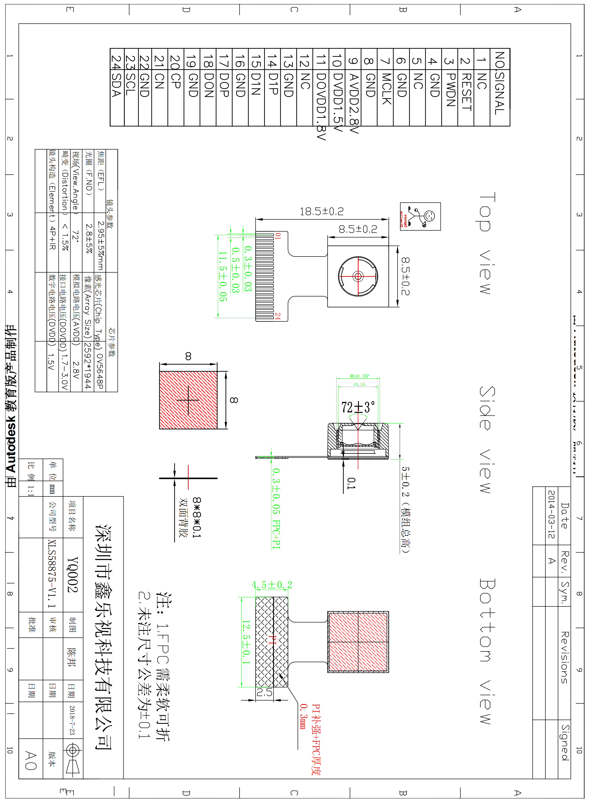

Connector Pin Assignment
Pin No. | Signal | I/O | Description | Remarks
1 | NC | NC | NC
2 | RESET | Input | Reset signal input (built-up resistance, low potential)
3 | PWDN | Input | power down（active high with internal pull-down resistor)
4 | GND | Ground | Ground
5 | NC | NC | NC
6 | GND | Ground | Ground
7 | MCLK | Input | Clock input
8 | GND | Ground | Ground
9 | AVDD2.8V | Power | Analog power supply
10 | DVDD1.5V | Power | Digital power supply
11 | DOVDD1.8V | Power | I/O power supply
12 | NC | NC | NC
13 | GND | Ground | Ground
14 | D1P | Output | MIPI data I positive electrode signal
15 | D1N | Output | MIPI data I negative electrode signal
16 | GND | Ground | Ground
17 | D0P | Output | MIPI data 0 positive electrode signal
18 | D0N | Output | MIPI data 0 negative electrode signal
19 | GND | Ground | Ground
20 | MCP | Output | MIPI clock positive eleetrode signal
21 | MCN | Output | MIPI clock negative electrode signal
22 | GND | Ground | Ground
23 | SCL | Input | SCCB serial interface clock input
24 | SDA | I/O | SCCB serial interface data IO
25
26
27
28
29
30

