
PRODUCT SPECIFICATION

USB 1080P

Camera Module

XLS-SM987-V1.0

Supplier confirmation
Department | Engineer | Quality inspector | Approver
Name / signature | [Li] | [Name / signature] | [Name / signature]
Date | [26-10-17] | [YYYY-MM-DD] | [YYYY-MM-DD]

Customer confirmation
Department | Structure / appearance | Electronics | Approver
Name / signature | [Name / signature] | [Name / signature] | [Name / signature]
Date | [YYYY-MM-DD] | [YYYY-MM-DD] | [YYYY-MM-DD]

Contact information
SHENZHEN SINOSEEN TECHNOLOGY


2nd Floor, Building C, Innovation Silicon Valley Industrial Park, Jingtian Road, Guanlan Guanhu Street, Longhua District, Shenzhen, China

https://www.sinoseen.com/


XLS-SM987-V1.0 / USB 1080P CAMERA MODULE

Product overview
Product description
USB 1080P camera module with a TBD-inch progressive-scan CMOS image sensor. The source specification lists full-resolution capture at TBD fps and applications including video conferencing, surveillance, document cameras, industrial inspection, identification, ATMs and access-control equipment.

Specifications and features
USB 2.0 plug-and-play operation; still-image capture (JPG, BMP) and video capture (AVI, MP4) through the capture software. Exposure time, color difference, brightness, contrast and saturation adjustment. Progressive-scan imaging; no interpolation.

Product details
Item | Specification | Item | Specification
Model | XLS-SM987-V1.0 | Interface | 4-pin, 1.0 mm USB 2.0
Video output | MJPG, YUY2 | USB signaling rate | 260 Mb/s
Supply voltage | 5 V ±5% | Microphone | Dual digital noise-reduction microphone
Operating temperature | 0°C to 50°C | Storage temperature | −25°C to 70°C
Power consumption | No LED: / | IR LED | /
OS support | Windows XP / Vista / 7 / 8 / 8.1 / 10 | Other OS support | Mac / Android / Linux 2.6.2 (UVC) / WinCE

Chip parameters
Item | Specification | Item | Specification
Sensor format | TBD-inch CMOS | Effective pixels | 1920× 1080
Pixel size | TBD | Sensor data output | 10-bit RAW
Maximum SNR | TBD | Dynamic range | TBD
Minimum illumination | TBD (no LED) | Optical distortion | <10%

Lens parameters
Item | Specification | Item | Specification
Lens mount | M6 × P0.25 | Construction | 4P
F-number | 2.4 ±5% | Effective focal length | 4.3 mm
Field of view | Diagonal: 73° ±3° | Focus distance | 60 cm to infinity

Maximum frame rates
Format | Resolution | Maximum frame rate
MJPG | TBD | TBD
MJPG | TBD | TBD
TBD = to be determined. “/” indicates no value provided in the source. Frame rates above are listed for MJPG; YUY2 mode details are not supplied.

XLS-SM987-V1.0 / USB 1080P CAMERA MODULE

Product structural drawing
Mechanical dimensions, image orientation and connector pin assignment
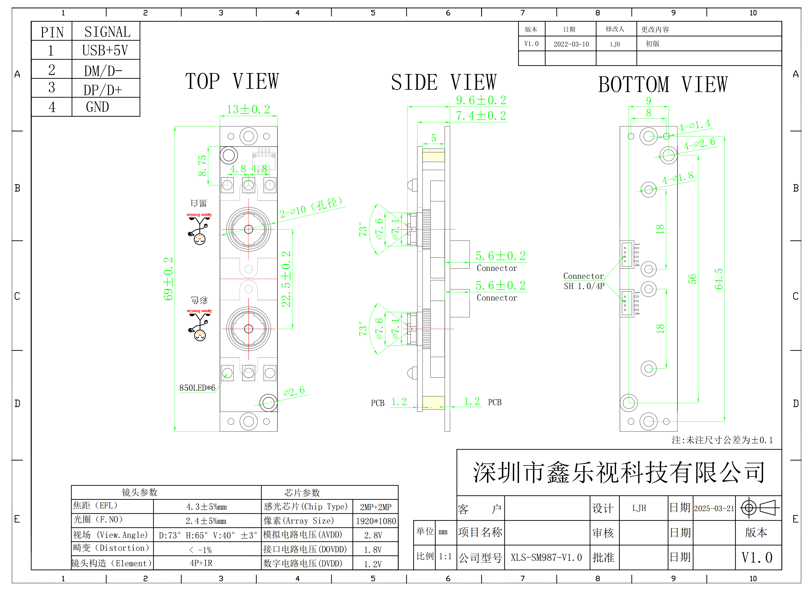

Drawing reference
Model: XLS-SM987-V1.0 | Units: mm | Drawing date: 2025-03-21
Revision markings: V1.0 / A0 | Unspecified dimensional tolerance: ±0.1 mm

USB connector pin assignment
Pin | 1 | 2 | 3 | 4
Signal | USB+5V | DM/D− | DP/D+ | GND
The structural drawing is retained from the source specification. Refer to the dimensioned drawing for assembly and inspection.

XLS-SM987-V1.0 / USB 1080P CAMERA MODULE

Product appearance specifications

Appearance inspection
# | Item | Requirements | Test method | Class
1 | Module appearance | No surface dirt, no scratches visible to the naked eye, and no impurities in the plastic. | 8× magnifier | A
2 | Lens | No visible scratches or dirt under 800 ±100 lux illumination, viewed head-on and with 45° reflected light. | 8× magnifier | A
3 | Thread adhesive | Adhesive length: 1/3 to 1/2 of the circumference. Adhesive must not overflow onto the lens end face or lens base. | 8× magnifier | A
4 | Sealant | Apply evenly between the base and PCB, without gaps or uneven thickness. No overflow beyond the FPC edge that causes the assembly dimensions to exceed the specified limits. | 8× magnifier | A
5 | PCB | Surface clean; printed characters legible. Edge burr: length <1 mm, width <0.3 mm. Edge notch: length <1 mm, width <0.1 mm; no more than 2 notches per edge. | 45× microscope  (continuous zoom) | A

Dimensional inspection
# | Item | Requirements | Test method | Class
1 | Height | Conform to the product drawing. | Digital caliper | A
2 | Length | Conform to the product drawing. | Digital caliper | A
3 | Width | Conform to the product drawing. | Digital caliper | A
Defect classes A and B are defined on the following page.

XLS-SM987-V1.0 / USB 1080P CAMERA MODULE

Product image specifications
Optical performance inspection requirements
# | Test item | Requirements | Test method | Class
1 | Dust | No visible foreign objects anywhere in the captured white-field image. | Test fixture; small light box; 6500 K white backlight | A
2 | Image orientation | Conform to the product drawing. | Test fixture | A
3 | Bright and dark pixels | Dark field: <400 bright pixels; <20 two-adjacent-pixel bright clusters; no bright clusters of more than 3 pixels. White field: <400 dark pixels; <20 two-adjacent-pixel dark clusters; no dark clusters of more than 3 pixels. | Test software; small light box; 6500 K white backlight | A
4 | Resolution | 1080P: center resolution ≥500 LW/PH. | MTF test procedure | A
5 | FOV | Diagonal: 73° ±3°. | Test fixture; FOV reference board | A
6 | Shading | At the four corner positions described as “90% away from the center”: mean corner brightness ≥45% of center brightness; each corner >35% of center. Sampling window: 40 × 40 pixels; sensor vignetting compensation disabled. | Test software; small light box; 3400 lux, 6500 K white backlight | A
7 | Color | Color reproduction error ≤20%. | Test software; color checker | A
8 | TV distortion | Pincushion (+) or barrel (−) distortion: no more than 1%. | Test software; ISO 12233 chart | A
9 | Grayscale | Brightness difference between adjacent gray levels <8. | Test software; grayscale chart | A
10 | CA | <0.5. | Test software; ISO 12233 chart | A
11 | Torque | ≥0.5 kgf·cm. | Torque wrench | A
12 | Thrust | ≥2 N. | Thrust gauge | A

Defect classification
A — Major nonconformity: affects image quality, principal functions or performance specifications, or results in rejection of the inspected batch.
B — General nonconformity: does not affect final product appearance, technical performance, or subsequent processing and assembly.
Source criteria retained. CA units, grayscale calculation, color-error method and the exact shading measurement positions require engineering confirmation before customer approval.

XLS-SM987-V1.0 / USB 1080P CAMERA MODULE

Product sampling plan

Imaging and reliability
# | Test item | Sampling plan | Test method / remarks
1 | Dust | Each batch: N=5, C=0 | Same as production; production inspection
2 | Image orientation | Each batch: N=5, C=0 | Test fixture; production inspection
3 | Bright and dark pixels | Each batch: N=5, C=0 | Same as production; production inspection
4 | Resolution | Each batch: N=5, C=0 | MTF test procedure; production inspection
5 | FOV | Each batch: N=5, C=0 | Test fixture / FOV board; QA sampling and full evaluation at sample stage
6 | Image uniformity | Each batch: N=5, C=0 | Test software; 3400 lux, 6500 K light box; production inspection
7 | Dispersion | Each batch: N=5, C=0 | Test software / color checker; QA sampling and full evaluation at sample stage
8 | TV distortion | Each batch: N=5, C=0 | Test software / ISO 12233 chart; QA sampling and full evaluation at sample stage
9 | Grayscale | Each batch: N=5, C=0 | Test software / grayscale chart; QA sampling and full evaluation at sample stage
10 | Reliability | Trial production: 2 pcs / production batch. Stable production: 5 pcs / test item / month. | Acceptance level: 0/1, as stated in the source.

Appearance
# | Test item | Sampling plan | Test method / remarks
1 | Module appearance | AQL=1.0 | Visual; production inspection
2 | Lens | AQL=1.0 | 8× magnifier; production inspection
3 | Thread adhesive | AQL=1.0 | 8× magnifier; production inspection
4 | Sealant | AQL=1.0 | 8× magnifier; production inspection
5 | FPC | AQL=1.0 | Visual; production inspection
6 | Gold fingers | AQL=1.0 | Visual; production inspection
7 | Steel stiffener | AQL=1.0 | Visual; production inspection
8 | Double-sided tape | AQL=1.0 | Visual; production inspection

Dimensions and mechanical checks
# | Test item | Sampling plan | Test method / remarks
1 | Height | AQL=1.0 | Same as production; production inspection
2 | Length | AQL=1.0 | Same as production; production inspection
3 | Width | AQL=1.0 | Same as production; production inspection
4 | Thread torque | Each batch: N=5, C=0 | Torque wrench; QA sampling
5 | Base thrust | Each batch: N=5, C=0 | Thrust gauge; QA sampling
N = sample size; C = acceptance number. AQL values are reproduced from the source; the governing sampling standard and inspection level are not specified.

XLS-SM987-V1.0 / USB 1080P CAMERA MODULE

Product reliability specifications
# | Test item | Conditions and requirements | Test equipment
1 | Low-temperature storage | −30°C for 48 h. Return to room temperature for 2 h before testing. | Low-temperature chamber + computer
2 | Low-temperature operation | −20°C; operate the product and inspect the image for 48 h. | Low-temperature chamber + computer
3 | High-temperature storage | 80°C for 48 h. Return to room temperature for 2 h before testing. | High-temperature chamber + computer
4 | High-temperature operation | 70°C; operate the product and inspect the image for 48 h. | High-temperature chamber + computer
5 | Aging | Operate at room temperature for 36 h and check for image abnormalities. | Computer
6 | Connector mating | Connector plugging / unplugging. Cycle count and detailed conditions are not specified in the source. | Workbench + computer
7 | Electrostatic discharge | Apply ±6 kV contact discharge and ±8 kV air discharge at the exposed copper grounding location. Apply 10 discharges per polarity at each point, with a 1 s interval. | ESD equipment + computer
8 | Free drop after packaging | Drop the packaged product freely from 150 cm, then check the image. | Oak floor + computer
9 | Vibration after packaging | Fix the packaged product to the test bench. Sweep 10–100–10 Hz; amplitude 2 mm; X, Y and Z directions; test duration 2 h as stated in the source. Check the image after testing. | Vibration test bench + computer

Acceptance requirements
After the reliability tests, dimensions, appearance, torque and optical performance must conform to the product requirements.

Post-test inspection conditions
Item | Condition
Small light box | 1500 lux ±10%
Large light box | 6000 lux ±10%
Color temperature | 4400 K ±150 K
Inspection system | PC test software / module test platform
Reliability test conditions are reproduced from the source and do not extend the rated operating or storage ranges on page 2. This page defines test requirements, not a completed test report.

