

User Manual
Pro Max / Pro Max Alpine Diesel Air Heater
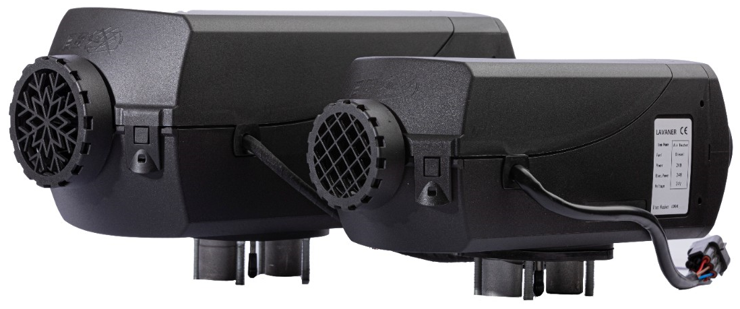
Version 1.0

Contents
1 | Important Safety Information
2 | Product Overview
3 | Before Operation
4 | Operating the Heater
5 | High-Altitude Operation
6 | Fuel and Cold-Weather Use
7 | Routine Care and Storage
8 | When a Fault Occurs
A | Technical Data

1 Important Safety Information
Exhaust gas hazard: Exhaust fumes can cause serious injury or death. Never operate the heater in a garage, enclosed parking structure, or any other closed or poorly ventilated space. Ensure the exhaust outlet terminates outdoors and cannot feed fumes into the vehicle.

- Switch the heater off before refuelling. Keep flames, sparks and smoking materials away from fuel and fuel vapour.
- Do not operate the heater where flammable vapours or combustible dust may accumulate, including near fuel, coal, wood or grain storage.
- Keep the heater-air intake, hot-air outlet, combustion-air intake and exhaust outlet clear at all times.
- Do not direct hot air at people, animals or temperature-sensitive objects.
- The heater and exhaust system become very hot. Allow all parts to cool before inspection or service.
- Do not open the heater casing or maintenance flap while the heater is operating.
- Use the normal controller shutdown procedure. Do not disconnect the battery or interrupt the automatic after-run/cool-down cycle except in an emergency.
- Do not modify safety-relevant components, wiring, fuel supply, combustion-air system or exhaust system. Use the correct fuse rating and approved replacement parts.
- Any fuel leak must be repaired before the heater is used again.
Installation: The heater must be installed and commissioned by qualified personnel in accordance with the separate Installation Guide, local regulations and the vehicle manufacturer’s requirements.

2 Product Overview

2.1 Intended use
The Pro Max / Pro Max Alpine diesel air heater operates independently of the vehicle engine. It is intended for suitable vehicles and equipment, including camper vans, passenger vehicles with up to eight seats, construction and agricultural machinery, trucks, and diesel-powered marine applications.
- Pre-heating and de-misting vehicle windows.
- Heating driver cabs, work cabs, passenger or crew compartments, ship cabins, freight compartments and camper-van interiors.

2.2 Prohibited use
- Permanent or long-term space heating in residential rooms, garages, huts, weekend homes or houseboats.
- Drying people, animals, clothing or other objects by direct hot-air flow.
- Blowing hot air into containers or enclosed objects.
- Any use outside the operating limits and installation requirements stated in the product documentation.

2.3 Main components
Component | Purpose
Heater unit | Generates and circulates heated air.
Smart Controller | Starts/stops the heater and controls heating, ventilation, timing and settings.
Dosing pump | Meters fuel to the heater.
Fuel line and dip tube | Connect the fuel source to the dosing pump and heater.
Combustion-air hose | Supplies clean air to the combustion chamber.
Exhaust pipe and silencer | Routes combustion exhaust safely outside.
Hot-air duct and outlet | Distributes heated air into the required space.
Wiring harness and fuses | Connects the heater, controller, pump and vehicle power supply.

3 Before Operation
Bench test: Before permanent installation, perform a bench test using the complete heater system. Contact the supplier if assistance is required.

1 | Confirm that the heater and all accessories are securely mounted and that no loose components can contact hot or moving parts.

2 | Inspect the complete fuel system for leaks, damaged hoses, loose clamps and air bubbles. Use fresh, suitable diesel fuel whenever possible.

3 | Check that the heater-air intake and outlet, combustion-air intake and exhaust outlet are unobstructed and protected from dirt, water and snow.

4 | Confirm that the vehicle battery and wiring can maintain the correct supply voltage during start-up and operation.

5 | Remove fuel cans, aerosols, cleaning cloths, paper, clothing and other stored items from the heater installation area.

6 | Check that the controller displays normally and that any previous fault code has been resolved before starting.

4 Operating the Heater

4.1 Starting heating
1 | Wake the Smart Controller by pressing any key if the screen is off.

2 | On the main interface, select the heating function and press the Power/OK key.

3 | Set the required running time. The available range is 10-120 minutes; after 120 minutes, the next setting is continuous operation (∞).

4 | Press the Power/OK key again to start heating.

5 | Adjust the heat level in manual mode or the target temperature in thermostat mode using the Left and Right keys.

4.2 Manual and thermostat modes
Mode | Display | Operation
Manual output mode | L1-L10 (for example L4) | The heater runs at the selected output level. Press and hold the Return key for 3 seconds to change mode.
Thermostat mode | Target temperature (for example 30 °C) | The controller adjusts heater output to maintain the selected temperature. Press and hold the Return key for 3 seconds to return to manual mode.

4.3 Stopping the heater
1 | Press and hold the Power/OK key for approximately 3 seconds.

2 | Wait for the controller to display OFF and for the heater to complete its automatic after-run/cool-down cycle.

3 | Do not disconnect the battery or isolate the main power supply until the heater has fully stopped.

4.4 Ventilation mode
Select the FAN icon, press Power/OK, set the required running time and press Power/OK again. Fan speed can be adjusted from L1 to L10. To end ventilation, press and hold Power/OK for 3 seconds.
Controller functions: Remote pairing, priming, clock settings, timers and status display are explained in the separate Smart Controller Manual. Priming should only be used after the initial power connection or after the power supply has been disconnected and reconnected.

5 High-Altitude Operation
Pro Max Alpine versions adjust fuel delivery automatically at altitude. No owner adjustment is required.
Heater | Automatic altitude range
Pro Max 2 kW Alpine | Sea level to 3,000 m (9,842 ft)
Pro Max 5 kW Alpine | Sea level to 5,500 m (18,044 ft)

Applicability: Automatic altitude compensation applies to Alpine versions. For a non-Alpine heater, consult the supplier before extended high-altitude use.

6 Fuel and Cold-Weather Use

6.1 Fuel quality
- Use commercially available diesel fuel meeting DIN EN 590 or the corresponding local standard.
- Never use waste oil or mixtures containing waste oil.
- When a separate tank is used, clearly identify the fuel type and keep the filler connection sealed.

6.2 Low-temperature fuel guidance
Ambient temperature | Fuel guidance
0 °C to -25 °C | Use 100% winter diesel.
-25 °C to -40 °C | Use 100% Arctic/cold diesel, or the winter-diesel blend specified by the supplier (50% winter diesel and 50% paraffin or petrol where legally permitted).

Fuel blending: Fuel requirements vary by country and vehicle. Observe local regulations and the fuel supplier’s instructions before adding paraffin or petrol to diesel.

After changing to winter diesel, Arctic diesel or an approved cold-weather blend, operate the heater for approximately 15 minutes so that the new fuel fills the fuel line and dosing pump.

7 Routine Care and Storage

7.1 After a long period of non-use
- Check that all parts remain securely mounted; tighten fasteners where necessary.
- Inspect the fuel system visually for leaks or damaged connections.
- Use fresh fuel where possible.
- Check that all air and exhaust openings are clear of insects, debris, corrosion, dirt and snow.
- Run the heater and confirm stable ignition, airflow and shutdown.

7.2 Periodic service
- Replace damaged fuses only with the specified rating.
- Have wiring faults, sensor faults, fuel leaks, abnormal noise or repeated shutdowns inspected by qualified service personnel.
- The heat exchanger is a high-temperature component and must be replaced 10 years after initial commissioning, as stated in the source heater manual.
- When using 100% biodiesel, run the heater on pure diesel twice per year - once during and once at the end of the heating season - for 2-3 cycles of approximately 30 minutes at the highest setting.

8 When a Fault Occurs
1 | Allow the heater to stop and cool. Do not repeatedly restart a heater that has failed to ignite or has overheated.

2 | Read the fault code shown on the Smart Controller.

3 | Check the basic items relevant to the code: supply voltage, fuel supply, air intake, hot-air outlet and exhaust path.

4 | Correct the cause of the fault before clearing the display.

5 | Use the separate Error Codes List for code-specific checks. Contact qualified service personnel for electrical, sensor, fan, glow-plug or internal heater faults.

Overheating: If the air outlet or heater body has overheated, do not restart until the airflow path is clear and the cause of the restricted airflow has been corrected.

Appendix A Technical Data
Parameter | 2 kW heater | 5 kW heater
Rated heating output | 2,000 W | 5,000 W
Heating medium | Air | Air
Fuel | Diesel | Diesel
Fuel consumption | 0.10-0.28 L/h | 0.16-0.51 L/h
Approx. weight | 2.7 kg | 4.5 kg
Heater air flow without counterpressure | 105 kg/h (source value) | 185 kg/h (source value)
Electrical consumption during operation | 8-34 W | 7-40 W
Rated voltage | 12 V or 24 V | 12 V or 24 V
Main dimensions (L × W × H) | 340 × 115 × 122 mm | 380 × 140 × 140 mm

Voltage protection
System | Undervoltage shutdown | Overvoltage shutdown | Trigger time
12 V | Approx. 10.5 V | Approx. 18 V | 20 seconds
24 V | Approx. 18 V | Approx. 28 V | 20 seconds

Temperature limits
Component | During operation | Not running
Heater | -41 °C to +55 °C | -40 °C to +85 °C
Dosing pump | -40 °C to +50 °C | -40 °C to +125 °C

Maximum heater-air intake temperature: +40 °C.

