

Installation Guide
Pro Max / Pro Max Alpine Diesel Air Heater
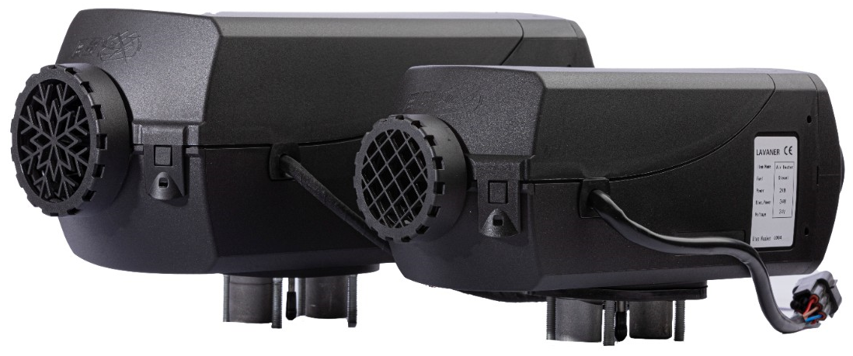
Version 1.0
Installation must be performed by qualified personnel

Contents
1 | Safety and Installation Planning
2 | Components and Specifications
3 | Installation Location and Orientation
4 | Mounting and Fastening
5 | Heater-Air System
6 | Exhaust System
7 | Combustion-Air System
8 | Fuel System
9 | Electrical Connection
10 | Commissioning and Final Checks
A | Service Reference

1 Safety and Installation Planning
Qualified installation: Installation and repair must be carried out by qualified personnel in accordance with this guide, applicable laws and the vehicle manufacturer’s requirements.

- Disconnect the vehicle battery before beginning any work.
- Switch the heater off and allow all hot components to cool before working on the heater, exhaust or air system.
- Do not modify the heater, ECU, safety sensors, wiring harness, fuel system, combustion-air system or exhaust system.
- Route fuel, electrical and brake lines away from hot exhaust components. Install heat shields where adequate clearance cannot otherwise be achieved.
- The heater must not create a fire risk, even during an overtemperature condition. Maintain clearance, ventilation and heat protection around the unit.
- The installed nameplate or a duplicate must remain visible and readable.
- Do not mount the heater in the passenger compartment of buses/coaches with more than nine seats unless the heater is installed in a compliant hermetically sealed enclosure.
- Exhaust gas must never be able to enter the vehicle through windows, ventilation openings, warm-air intakes or other openings.
Bench test: Assemble and bench-test the complete system before drilling the vehicle or completing the permanent installation.

2 Components and Specifications

2.1 Scope of supply
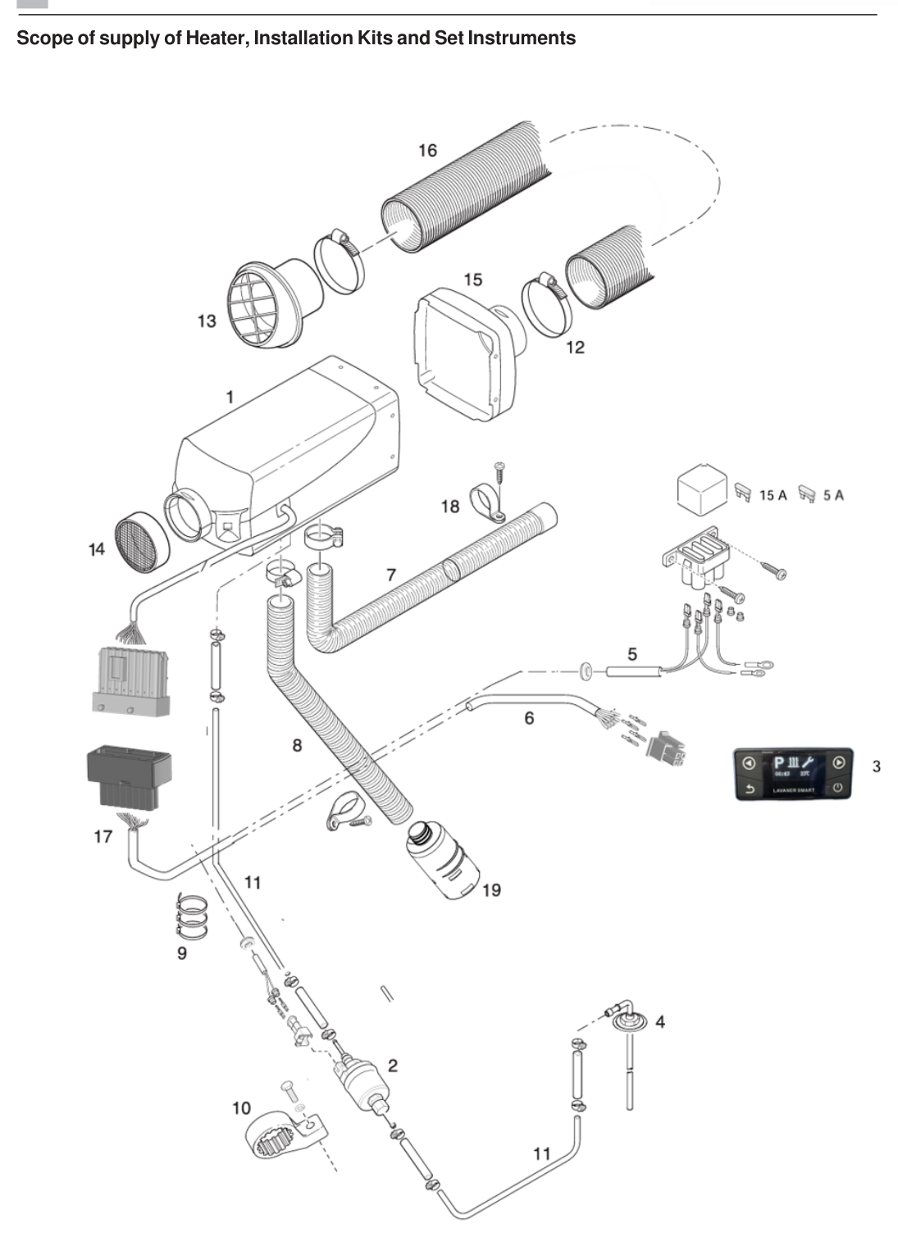
Typical heater and installation-kit components
No. | Component | No. | Component
1 | Heater | 11 | Fuel hose
2 | Dosing pump | 12 | Air-duct clamp
3 | Smart Controller | 13 | Rotary air outlet
4 | Fuel dip tube | 14 | Safety grid
5 | Fuse | 15 | Rear housing
6 | Wiring harness | 16 | Air duct
7 | Flexible exhaust pipe | 17 | Connector
8 | Combustion-air intake pipe | 18 | P-shaped clamp
9 | Clamp | 19 | Air-intake silencer
10 | Dosing-pump bracket

2.2 Technical data
Parameter | 2 kW | 5 kW
Output | 2,000 W | 5,000 W
Fuel consumption | 0.10-0.28 L/h | 0.16-0.51 L/h
Fuel | Diesel | Diesel
Approx. weight | 2.7 kg | 4.5 kg
Air flow without counterpressure | 105 kg/h (source value) | 185 kg/h (source value)
Electrical consumption in operation | 8-34 W | 7-40 W
Rated voltage | 12 V or 24 V | 12 V or 24 V
Dimensions | 340 × 115 × 122 mm | 380 × 140 × 140 mm

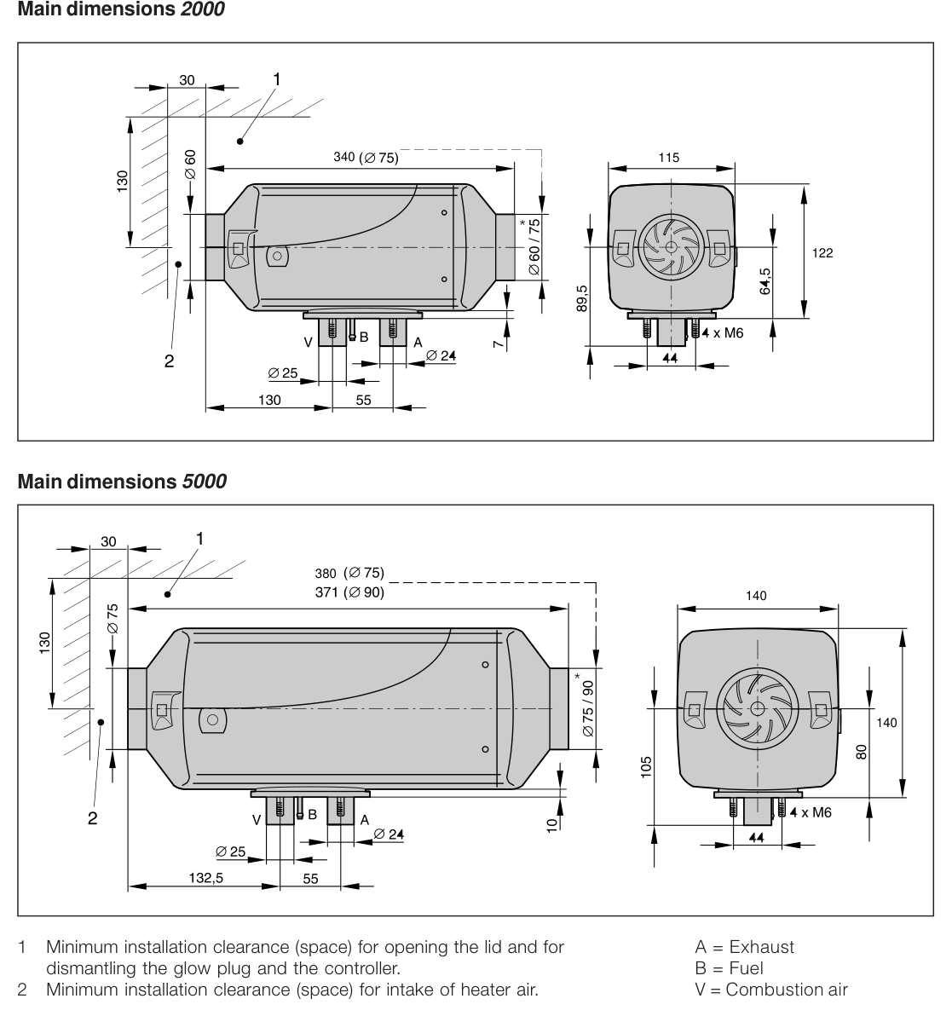
Main dimensions and required service clearances

3 Installation Location and Orientation

3.1 Location requirements
- Provide sufficient clearance for the heater-air intake and for removal of the glow plug and controller.
- When the heater is installed in a compartment used by people, exhaust, combustion-air and fuel pipes in that area must have no detachable connections and must pass through the floor or wall in a splash-resistant manner.
- The support surface must be flat, smooth and strong enough for the heater and vibration loads.
- The heater-air intake must draw clean fresh or recirculated air that is not contaminated by engine exhaust, heater exhaust, dust or salt spray.
- The hot-air outlet must be protected from blockage and arranged so it cannot cause injury or heat damage.

3.2 Typical locations
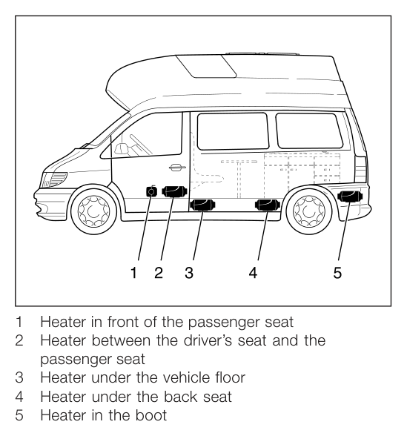  Camper-van installation locations | 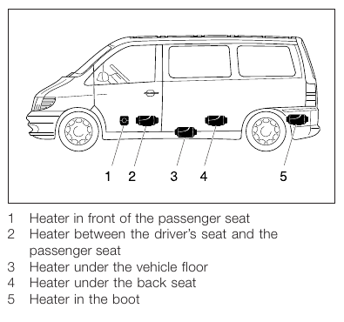  Car or people-carrier locations

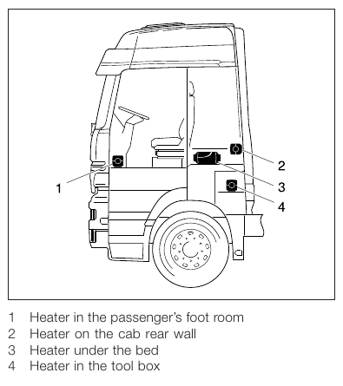  Truck-cab locations | 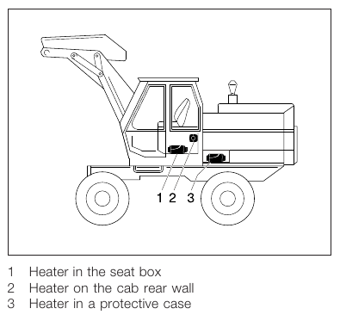  Excavator-cab locations

The illustrated locations are examples. Other locations are acceptable only when all safety, orientation, clearance, temperature and routing requirements are met.

3.3 Permitted orientation
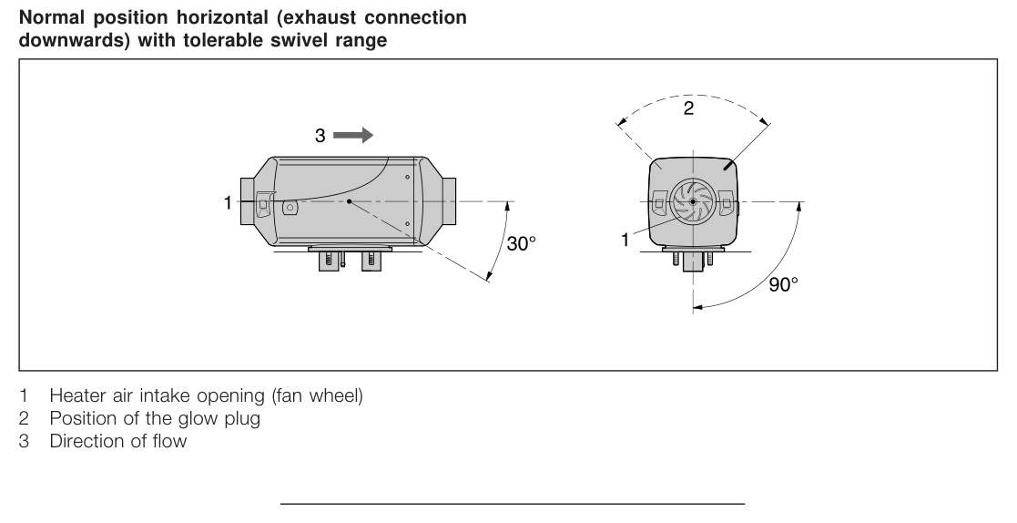
Permitted heater orientation and swivel range
- Preferred position: horizontal, with the exhaust connection facing downward.
- The heater may be tilted by up to 30° with the airflow direction downward.
- It may be rotated by up to 90° around its longitudinal axis, with the exhaust connection horizontal and the glow plug pointing upward.
- During operation, vehicle or boat inclination may deviate by approximately 15° from the installed limit without impairing function.

3.4 Wiring-harness side
If required, the heater cable-harness exit can be moved to the opposite side. Remove the controller and lower semi-circular cable cover, reroute the harness, then reinstall the controller, housing shell, harness bush and sealing plugs correctly.
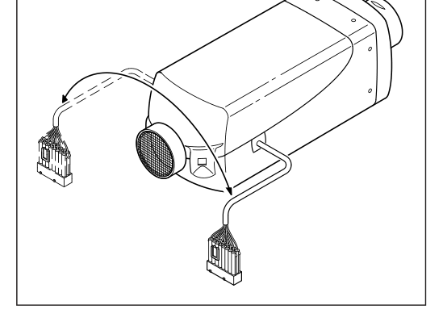
Cable-harness connection can be routed to the left or right

4 Mounting and Fastening
1 | Mark and cut the openings for exhaust, combustion air and fuel according to the mounting pattern.

2 | Prepare a flat, smooth bearing surface for the heater foot.

3 | Drill the separate Ø10.5 mm opening for the dosing-pump harness after locating the installation.

4 | If the supporting sheet metal is thinner than 1.5 mm, install a reinforcement plate.

5 | Fit the flange seal between the heater foot and the vehicle floor or wall.

6 | Confirm that the fan wheel rotates freely and that the heater has the required service and intake clearance.

7 | Secure the heater using M6 fasteners. Tighten the M6 hexagon nuts to 5 +1 N·m.

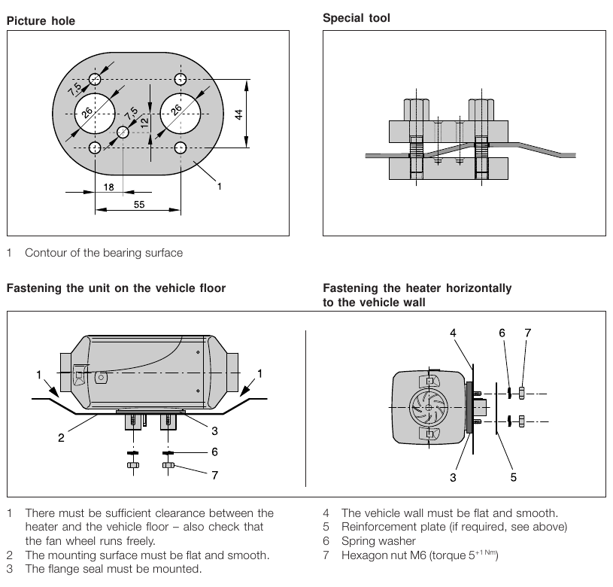
Hole pattern, support preparation and mounting arrangements

5 Heater-Air System
Burn hazard: The hot-air system can reach very high temperatures during and after operation. Route and guard ducts and outlets so that people, animals and temperature-sensitive materials cannot be burned or damaged.

- Fit the outlet hood on the heater hot-air side.
- If no duct is installed, fit a safety grid to the heater-air intake and outlet.
- Use only temperature-resistant hot-air ducting approved for the heater.
- Do not position a recirculated-air intake where it can immediately draw the heater’s own hot outlet air back into the unit.
- Protect the intake from engine/heater exhaust, dust and salt spray.
- Where occupants could touch the heater, install contact protection.
- During commissioning, after approximately 10 minutes of operation, the average outlet temperature measured about 30 cm from the outlet should not exceed 110 °C when intake air is approximately 20 °C.
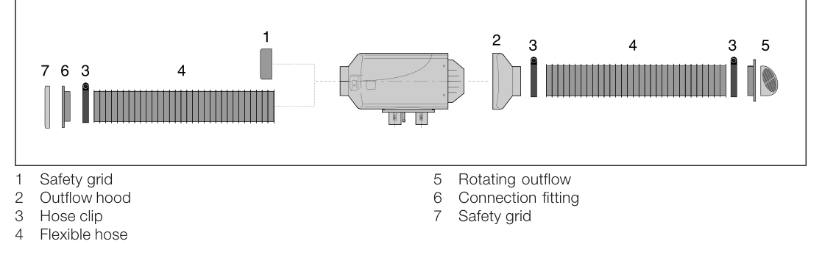
Typical heater-air duct arrangement

6 Exhaust System
Toxic exhaust and high temperature: The exhaust outlet must terminate in open air. Never route exhaust where fumes can enter the vehicle or be drawn into the combustion-air or heater-air intake.

- The installation kit includes a flexible exhaust pipe with an inner diameter of 24 mm and an exhaust silencer.
- The flexible exhaust pipe may be shortened to a minimum of 0.2 m or extended to a maximum of 2 m, depending on installation conditions.
- Route the pipe slightly downward. If required, drill an approximately Ø5 mm drain hole at the lowest point for condensation.
- Do not allow the exhaust outlet to protrude beyond the side of the vehicle or point in the direction of travel.
- Protect the exhaust outlet from dirt, snow and water.
- Maintain clearance from fuel lines, electrical cables, brake hoses and other heat-sensitive components.
- Secure the exhaust pipe against vibration at approximately 0.5 m intervals and fasten the silencer to the vehicle.
- If a silencer is installed, keep the outlet tailpipe substantially shorter than the flexible pipe between the heater and silencer.

7 Combustion-Air System
- Use combustion-air hose with an inner diameter of 25 mm.
- The combustion-air opening must remain free at all times and must not face directly into the slipstream.
- Position the intake so that exhaust fumes cannot be drawn into the heater.
- Protect the intake from wind, snow, dirt and water.
- Route the hose slightly downward; if necessary, provide an approximately Ø5 mm condensation drain at the lowest point.
- Secure the hose to the heater with a clamp and support it with hose clamps or cable ties.
- The routing shown in the source guide allows a typical length range of approximately 0.2-2 m.
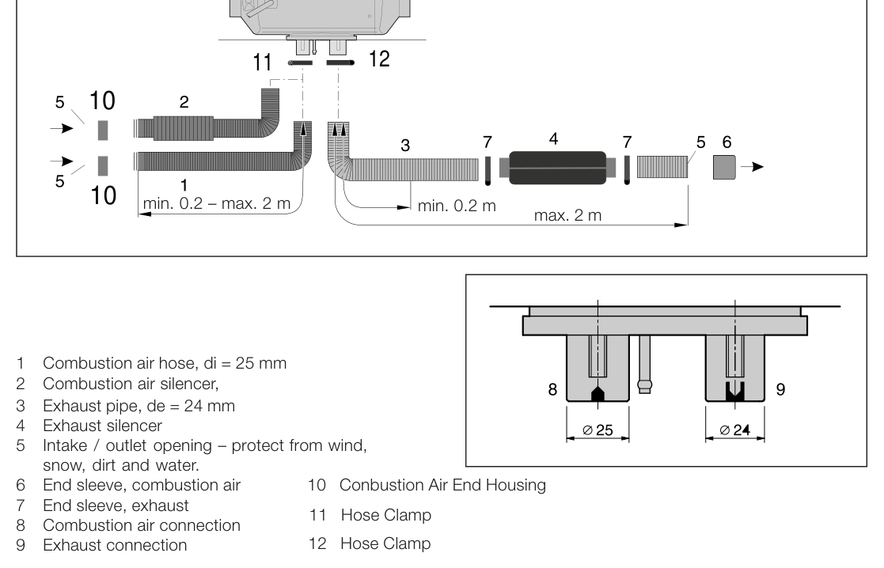
Combustion-air and exhaust routing, connection diameters and maximum lengths

8 Fuel System
Fuel safety: Switch off the vehicle engine and heater before refuelling or working on the fuel system. No smoking, flames or sparks. Avoid inhaling fuel vapour and avoid skin contact.

8.1 Fuel-line routing
- Cut fuel hose and pipe squarely with a sharp tool. Connections must not be crushed and must be free of burrs.
- Route the fuel pipe from the dosing pump to the heater with a continuous upward rise.
- Support fuel lines at approximately 0.5 m intervals to prevent vibration damage and noise.
- Protect the fuel line from mechanical damage, vehicle movement and heat.
- Never attach the fuel line to the heater exhaust. Where systems cross, maintain adequate heat clearance or install a heat shield.
- Connect rigid fuel pipes in a butt joint inside the hose to prevent air-bubble formation.
- Install the supplied fuel filter to reduce the risk of dosing-pump blockage.
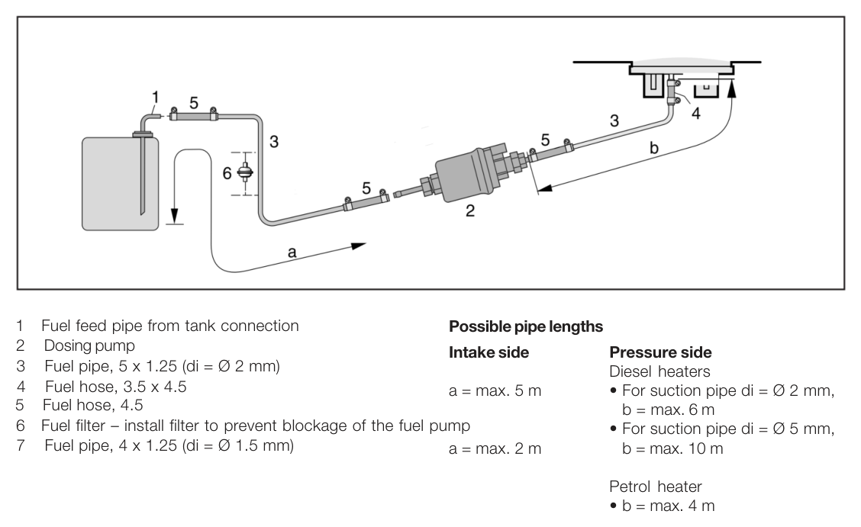
Typical fuel-line arrangement and source-manual length limits
Fuel-pipe internal diameter | Maximum intake-side length a | Maximum pressure-side length b (diesel)
Ø2 mm | 5 m | 6 m
Ø5 mm | 2 m | 10 m

8.2 Dosing-pump height and angle
Parameter | Maximum / permitted value
Tank-to-pump pressure height (a) | 3,000 mm
Intake height in a pressureless diesel tank (b) | 1,000 mm
Intake height with tank-cap vacuum valve (b) | 400 mm
Pump-to-heater pressure height (c) | 2,000 mm
Pump mounting angle | More than 15°; preferred 15°-35°; permitted up to 90°

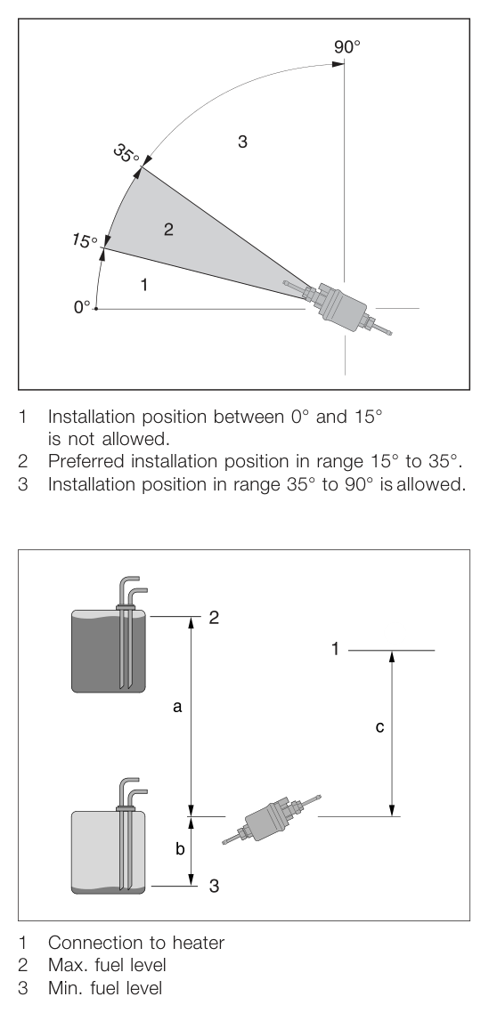
Dosing-pump height limits and permitted mounting angles
- Mount the pump with the pressure side rising upward by at least 15°.
- Do not mount the dosing pump or fuel filter near the exhaust pipe or silencer.
- Do not gravity-feed or pressurise the heater fuel supply. Do not take heater fuel downstream of the vehicle fuel pump.
- Where vehicle fuel-line pressure exceeds 0.2 bar, use an approved pressure reducer or a separate tank connection. Where pressure exceeds 4.0 bar or the return line includes a non-return valve, use a separate tank connection.

9 Electrical Connection
Electrical safety: Disconnect the battery before wiring. Use the correct system voltage and fuse ratings. Do not alter wire sizes, connectors or safety-related circuits.

- Connect the heater to the vehicle positive and negative supply as shown in the wiring diagram.
- The source diagram shows a 15 A main fuse and a 5 A auxiliary/controller circuit fuse. Use only the ratings specified for the supplied harness.
- Connect the controller, dosing pump, fan motor, glow plug and temperature sensor only through the correct keyed connectors.
- Protect wiring from abrasion, moisture, heat and moving parts.
- Before electric welding on the vehicle, disconnect the battery positive cable and protect the heater controller/ECU from welding current.
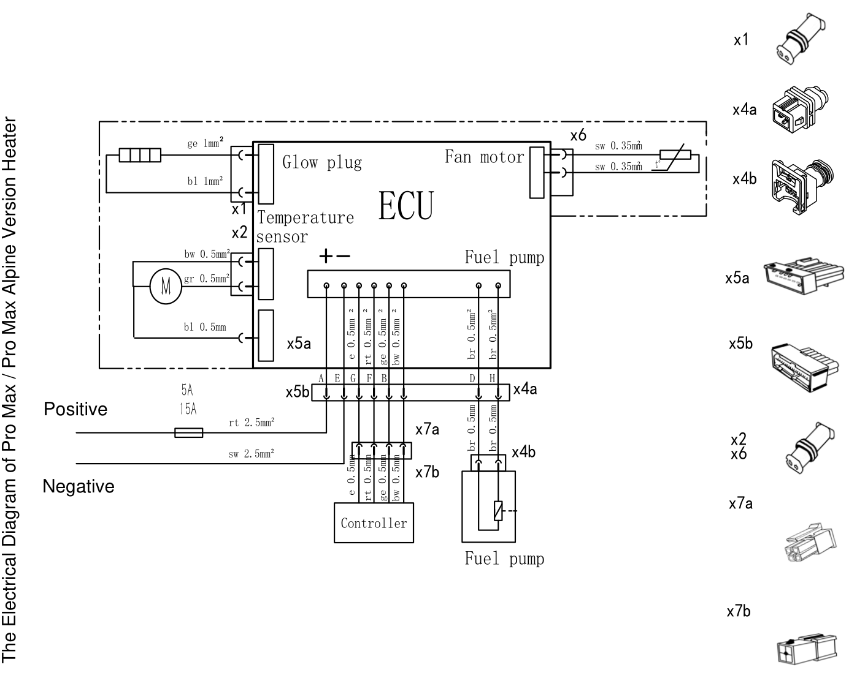
Electrical diagram for Pro Max / Pro Max Alpine heater

10 Commissioning and Final Checks
1 | Confirm that the heater, pump, silencers, ducts, hoses, wiring and all clamps are securely mounted.

2 | Check that the nameplate remains visible and record the year of initial commissioning.

3 | Inspect the fuel circuit for leakage and verify that the rigid pipes meet correctly in butt joints.

4 | Verify that the exhaust terminates outside, points away from the direction of travel and cannot be blocked by snow or dirt.

5 | Verify that the combustion-air intake is separated from exhaust and cannot draw in fumes.

6 | Verify that the hot-air intake and outlet are clear and that no stored items can contact the heater.

7 | Prime only as required, then start the heater and confirm stable ignition, fuel-pump operation, fan operation and unobstructed airflow.

8 | After approximately 10 minutes, confirm that the average air temperature about 30 cm from the outlet is no more than 110 °C at an intake temperature of about 20 °C.

9 | Stop the heater using the controller and confirm that the automatic after-run completes without interruption.

10 | Check again for fuel leakage, exhaust leakage, abnormal noise, overheating, loose fasteners and fault codes.

Do not release the vehicle: Do not place the heater into service if there is any fuel or exhaust leak, repeated ignition failure, abnormal noise, blocked airflow, overheating or unresolved fault code.

Appendix A Service Reference
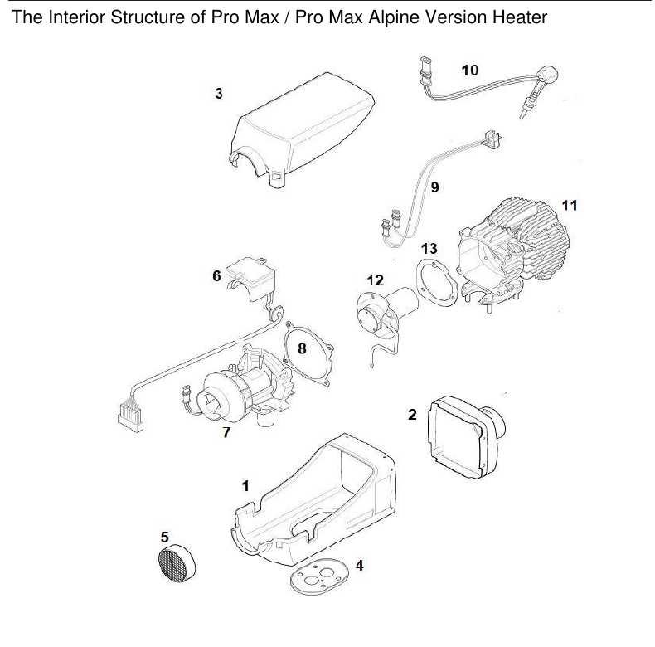
Exploded-view reference for Pro Max / Pro Max Alpine heater. Internal service must be carried out by qualified personnel.
No. | BOM part | No. | BOM part
1 | Lower housing | 8 | Gasket
2 | Rear housing | 9 | Temperature sensor (Pro Max)
3 | Upper housing | 10 | Kyocera glow plug
4 | Seal rubber gasket | 11 | Heating exchanger
5 | Safety grid | 12 | Burner
6 | ECU board | 13 | Gasket
7 | Motor fan assembly (brushless)

Heat exchanger: Replace the air-heater heat exchanger 10 years after initial commissioning. Record the installation date and follow the applicable service procedure.

