Catalog
Preface 02
Installation
1. Connect electricity. Take the air . Add water 03
2. Install the conveyor and gun head 04
Switch on and off 05
Parameter adjustment
1. Home page interface 05
2. Process interface 06
3. Set the interface 07
4. Debugging of wire feeder 08
Debug focus 09
Replace the protective glasses 10
Maintenance 11
Process reference table 12
Fault and handling 13

Preface
Thank you for purchasing the fiber laser welding machine of Zhengzhou Puhua Laser Technology Co., Ltd. If it is the first time for you to use this product, please be sure to read this manual carefully before installation and use. Please carefully read the contents marked with "danger", "warning", "attention" and so on in this manual, and carefully identify the safety signs on the equipment, so as to ensure the safety of you and the surrounding personnel and the correct use of the equipment.
- Ensure reliable grounding when using the machine to avoid possible personal injury.
- The laser is invisible. Do not point the laser head at a place where there are people. Do not look directly at the laser output head.
- When the laser is cooled by water, it is necessary to ensure that there is enough water flow for heat dissipation. The cooling water is distilled water, and it is recommended to replace it once every three months to ensure the quality of the cooling water and prevent the blockage of the waterway from affecting the cooling effect.
- In order to protect the welding joint and ensure the welding effect, it is necessary to work with shielding gas. It is strictly prohibited to emit laser without shielding gas. Argon is recommended as a shielding gas.
Identification | Explain
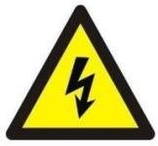 | Danger! Be careful of electric shock 。 Precautions for electrical safety, which may cause electric shock and personal injury.
 | Warning! Watch out for the laser 。 Precautions for laser radiation. There is a risk of laser radiation. Please take laser protection measures.
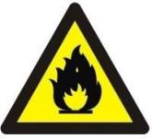 | Warning! Be careful of fire 。 Precautions for fire safety, which may cause fire, pay attention to fire prevention.
 | Careful! Be safe 。 General danger symbol. If you do not follow the prompt, it may cause damage and failure of the equipment.

Installation
The power line and the protective gas access pipe are fixed at the rear of the machine, and the output voltage of 380 V is connected to the electrical box according to the line mark. The gas tube is connected to the inert gas argon (the diameter of the gas tube of the connector is 10 mm).

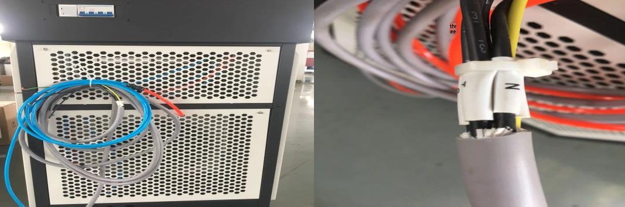

The handheld bonder uses a water cooling system to provide head and laser cooling. Open the front door of the cabinet and inject softened water into the water injection port, such as purified water, distilled water, high-purity water, etc.

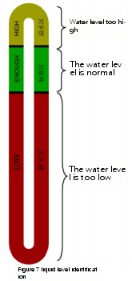
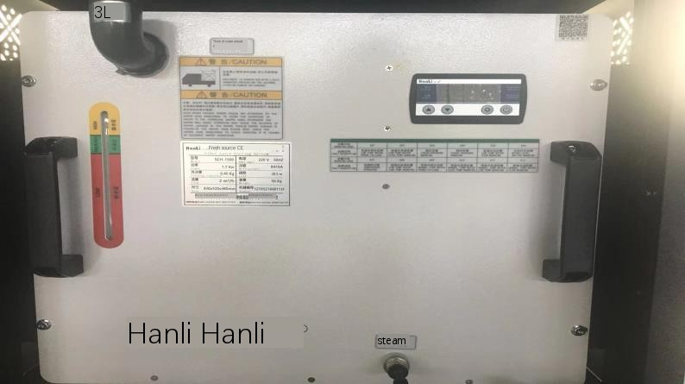

The company's hand-held welding machine is equipped with dual-drive power wheel wire feeder, which can use ordinary solid welding wire in the market and select the corresponding welding wire according to the product. The diameters of the welding wires to be installed are 0.8, 1.0, 1.2 and 1.6 respectively, and corresponding wire feeding wheels and wire feeding nozzles are provided. A wire feeding wheel and a wire feeding nozzle matched with the corresponding welding wire are required to be installed during installation.

The three-hole socket at the rear of the cabinet is used to supply power for the wire feeder, and other electrical appliances are not allowed to be connected. The rear of the wire feeder is respectively provided with a two-eye signal quick plug and a three-eye power quick plug, wherein the two-eye signal male plug of the wire feeder is in short circuit with the automatic wire feeding machine. The wire feeding pipe shall be fixed with cross screws, and the screws can be loosened and tightened during disassembly and assembly.
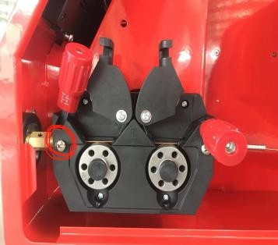
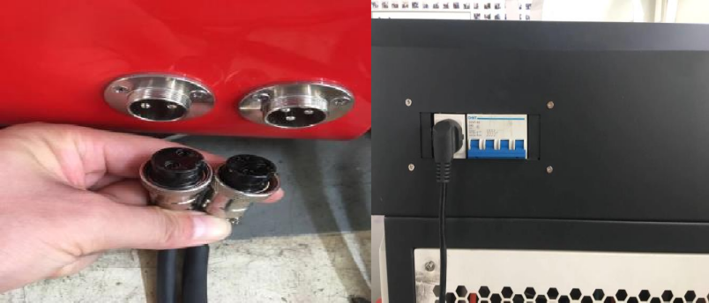

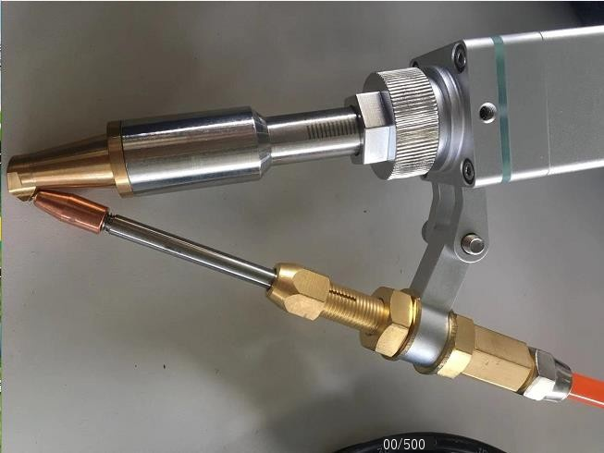
The hand-held welding machine of our company has been tested when it comes out of the factory. Each position of the welding gun has been debugged. The best position can be used directly for welding. It is recommended to record the scale position on the scale tube. Generally, the focus position is also a common position for welding. When the wire guide nozzle is installed, the wire guide nozzle is contacted with the clamping groove position of the wire feeding copper nozzle and is not allowed to be contacted with the clamping groove position of the wire feeding copper nozzle, so as to prevent light breakage or unsmooth wire breakage; the wire feed copper nozzle is installed on a straight line, and meanwhile, a wire clamping position of a wire feed copper nozzle is a central position relative to a gun body.
Wire guide nozzle
Wire feeding copper nozzle

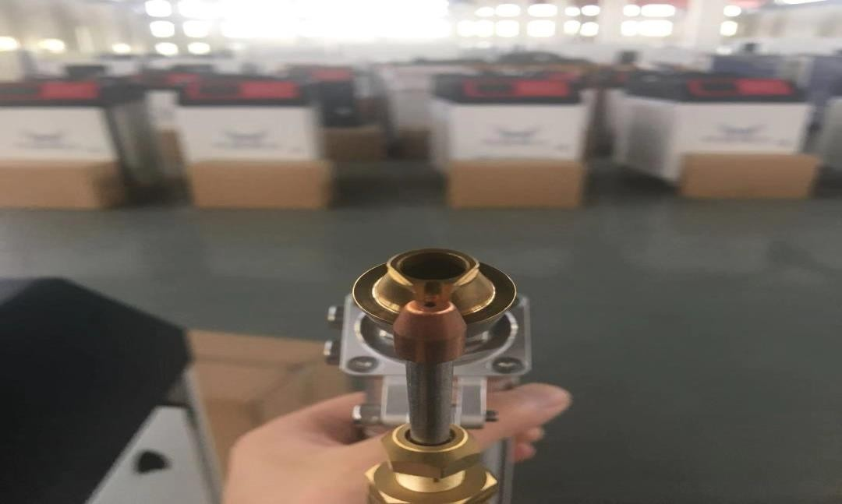

Switch on and off
The main switch of the machine is located at the rear of the cabinet. Unscrew the front emergency stop switch. Press quickly in case of emergency.
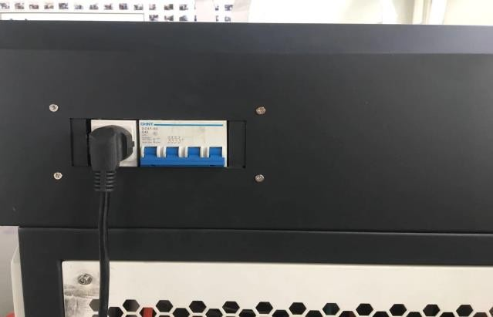

Parameter adjustment

There is text explanation for "HELP" in the upper right corner of the process interface and setting interface
The home page interface can control the laser light enable. When the laser enable is turned off, the machine will not work without any alarm.
05

Out of the light. When the operator leaves for a short time or other needs, the enable can be turned off to prevent the light from being emitted by mistake. A safety lock is mainly use for detecting whet a welding gun touches a workpiece to be welded and preventing a safety mechanism from emit light by mistake. When the welding gun, the welding workpiece and the safety lock clamp are in contact with the access, the safety lock lamp can emit light normally when it turns green, and it cannot emit light when it turns gray, indicating that there is an open circuit.
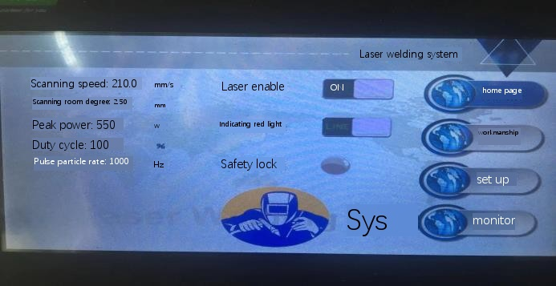
The process interface is mainly used to adjust common parameters, change power and light spot width (width selection is based on the diameter of the welding wire, for example, 1.0 welding wire selects the light spot as 1.0 + 0.6 + 0.6, which is the minimum light spot size), such as plate thickness and welding wire thickness or change. Generally, the scanning speed is 200-250, the duty cycle is 100, and the pulse frequency is 1000 +, which does not need to be changed. Reduce the duty cycle by about 70 and the pulse frequency by about 5-15 during fish scale welding. The specific parameters are changed according to the actual requirements of the product. Change completed, import and save. The new version has welding mode selection, which is divided into continuous welding and spot welding. When spot welding is used, the welding time needs to be set (setting interface). The welding time is the time of light emission. Press the button once or press it for a long time as a signal, and the light emission is once.
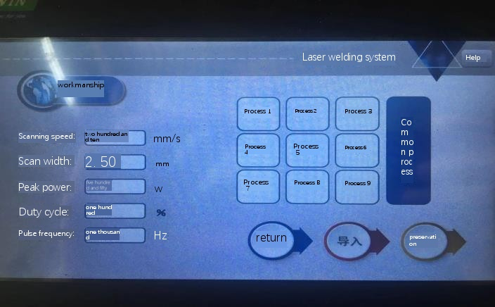

The setting interface is a background setting, which will not be changed after debugging. Password: 123456. After opening the setting interface: * Laser power, scanning correction, laser alarm level, water cooler alarm level, air pressure alarm level are absolutely not allowed to be changed, and the damage caused by unauthorized changes shall be borne by the customer *

Gas opening delay, when the button is pressed, the protective gas is released first and then the laser is released.
Gas closing delay. When the welding is finished and the button is released, the protective gas will continue to come out after the laser is finished. Time unit: millisecond. When the welding must be vertical or the muzzle is upward, the service life of the protective lens can be prolonged by increasing the delay time of closing the gas.
The light on power and the light on gradual time are used together. For example, the two parameters are written in 80% and 300ms. When the switch button is pressed, the gas is discharged first and then the light is discharged. The laser power reaches 100% of the given power in 300ms at 80% of the given power. Use of these two parameters can reduce the chance of lens damage when welding in high power and low temperature environments.
The light-off power and the light-off progressive time are used together, and the logic is opposite to the light-on power and the light-on progressive time. The wire can be broken more easily by using the gradual time of closing light and the wire returning function of the wire feeder. The parameter is "0" when the spot-weld function is used.
Laser offset, the spot position of the hand-held welding machine can be adjusted. In general, better welding effect can be obtained if the light spot is located at the center of the welding wire. When it is confirmed that the position of the wire feeding copper nozzle is relatively positive, and the position of the red light is seriously shifted relative to the welding wire, the red light can be shifted to the left or right by changing the parameters. Negative value to the left, positive value to the right, range
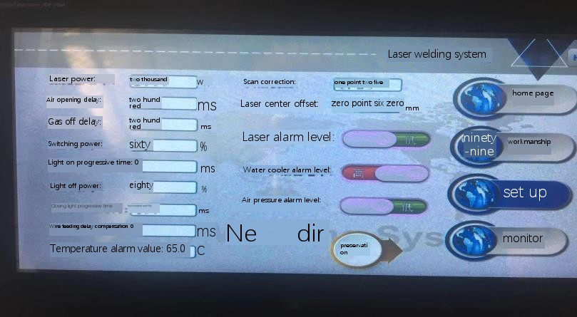
-2~2。

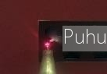
Spot welding mode. When the product only needs spot welding, it can be used. Press the switch once for spot welding. When the time is less than the set time, press the time to emit light. When the time is long, press the time to emit light as the set time (spot welding duration), and then stop the light as the set time (spot welding interval). The tack weld duration is less than the tack weld interval when using tack weld mode.
Fish-scale welding. Fish scale weld is a kind of laser fish scale weld developed according to that characteristics of argon arc weld. Because the argon arc welding has high requirements for personnel for a long time, the tungsten needle is frequently replaced. When customers have special needs, it is generally not recommended to use. Sealing and firmness are inferior to continuous welding under the same conditions. It will shorten the life cycle of the lens.
Fish scale welding is similar to spot welding for a long time. According to the interval of spot welding, repeated light is produced, and the spot welding spots form a fish scale shape. The parameter settings are matched according to the tack weld duration, interval time and wire feed speed. The welding duration can be lengthened (the increase ratio is limited) if the welding depth is required to be large or the welding spot is large. For example, the difference between the duration of spot welding and the interval time of electric welding is small if it needs to be dense, otherwise it is large. The duration of spot welding is much longer than the interval of spot welding in fish scale welding.
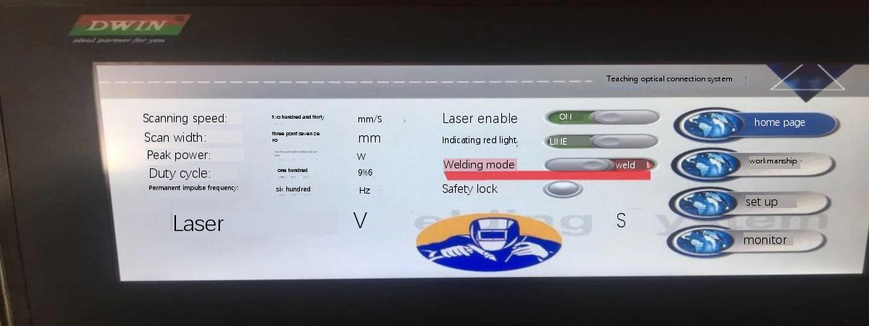
The spot welding mode switch is located on the home page, and the fish scale welding, the spot welding duration, and the spot welding interval are located on the setting page.

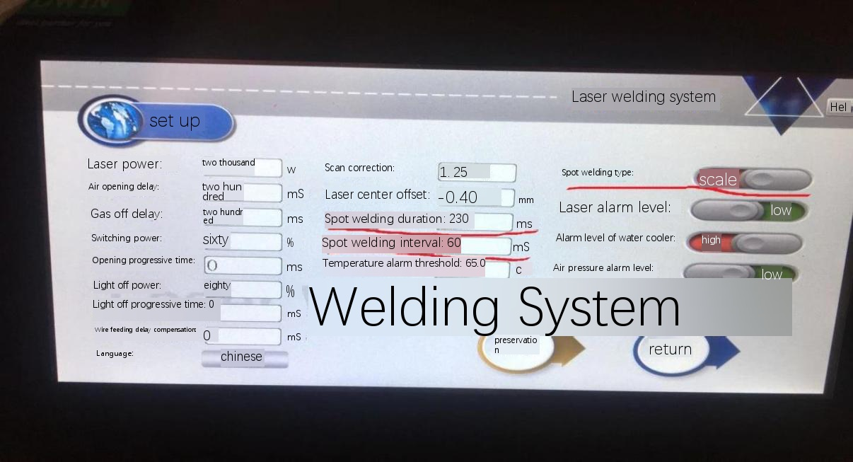

The wire feeder is standard. When there is a gap in the welding product or the weld bead is required to be beautiful and full, the requirements can be met by wire welding.
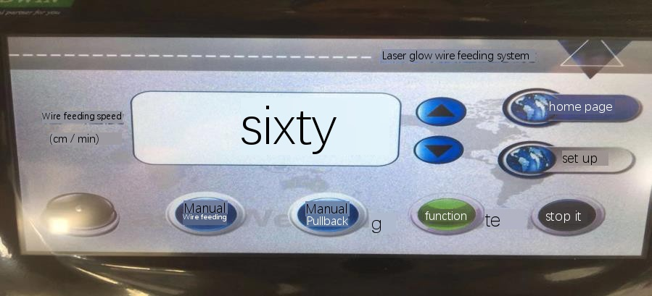
The first page displays the basic parameters, which can directly change the wire feeding speed, wire feeding, wire returning (the wire returning distance shall not exceed one meter), stop and operation. When there is no need for wire welding, just click to stop.

Start delay. When the welding torch light button is pressed, the wire feeder starts to feed the wire after the given parameter time is extended. This parameter can be used to prevent missing welds at the lap joint when the welding of a long weld needs to be stopped halfway.
Withdraw the length. After welding, release the switch button to recover the welding wire, so as to separate the welding wire from the workpiece. It is used in conjunction with the gradual time of closing light in the control system. The appropriate length is judged to be flush with the red light and the welding wire.
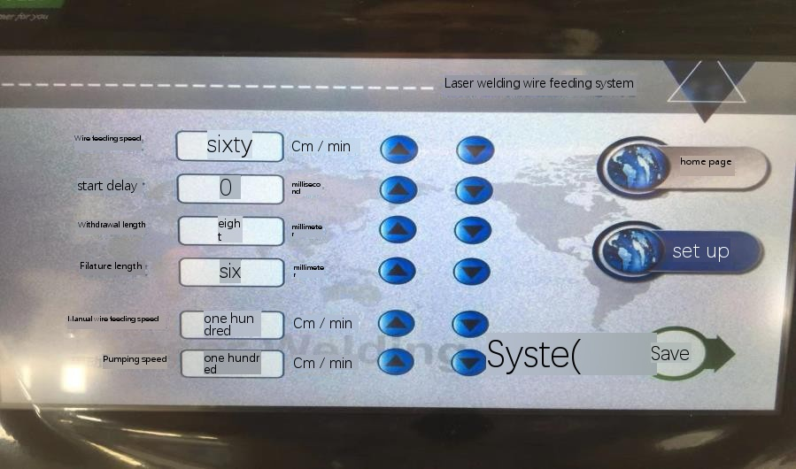
The length of the welding wire shall be supplemented, and the welding wire shall be extended out by one section after the withdrawal. Withdraw too much or reserve a part of the welding wire for use. It can also be directly adjusted by pumping back.

Debug focus
The laser passes through the focusing mirror to form the minimum point, the intersection of the two lines "X". In general, welding at the focal point is used, and the energy is the strongest. The position of the focus relative to the workpiece is adjusted through the expansion and contraction of the scale tube, so that the focus is just positioned on the surface of the welding workpiece. By judging the spark and sound, it is judged whether it is on the surface of the workpiece. It must be ensured that the lens is intact. When stainless steel is used, it is easier to judge if the scanning speed in the welding process is changed to "0" and the scanning width is changed to "0" and the power to "260-300".
There are sparks similar to holding fireworks sticks, and there is a crisp "silk" sound, which is judged as the focus position.
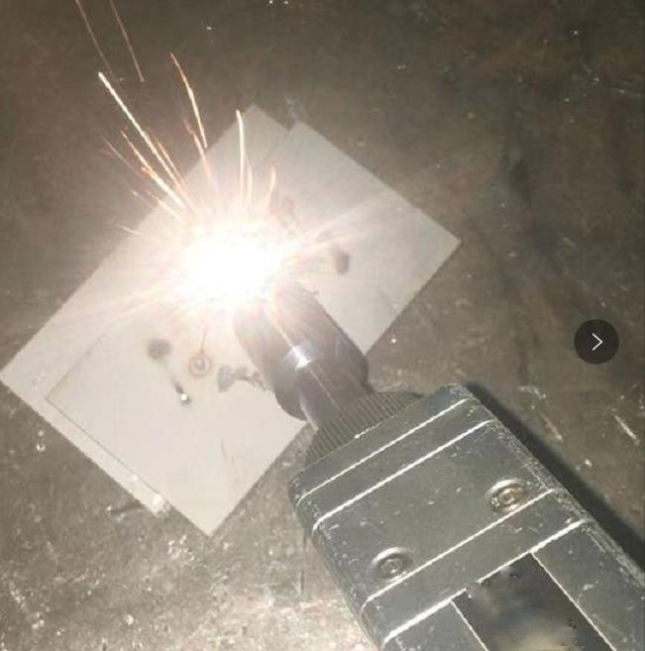
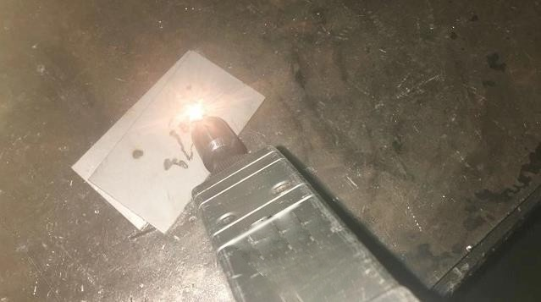
No spark, no sound, defocus position (check the lens if this occurs when the focus is correct)

Replace the protective glasses
Due to the processing characteristics of laser welding, the lens needs to be maintained regularly. If the protective lens has serious burn marks, the protective lens needs to be replaced.
Before operation, wash and dry your hands with detergent, wipe the gun body clean, remove the screws of the protective mirror compartment cover in a relatively dust-free and windless place, and pull out the protective mirror bracket.
Check the protective lens, and rotate the metal ring to take out the lens. Then check the white power storage seal ring under the protective lens.
(If the power storage seal ring is scratched or deformed, it cannot be used and must be replaced immediately.)
Wipe the compartment opening and the inside of the compartment cover with a cotton ball dipped in alcohol, quickly insert the protective mirror bracket into the protective mirror compartment, and tighten the screws. The transparent surface of the new mirror is not allowed to be touched directly by hand. The index finger and thumb pinch the side of the lens and put it in.

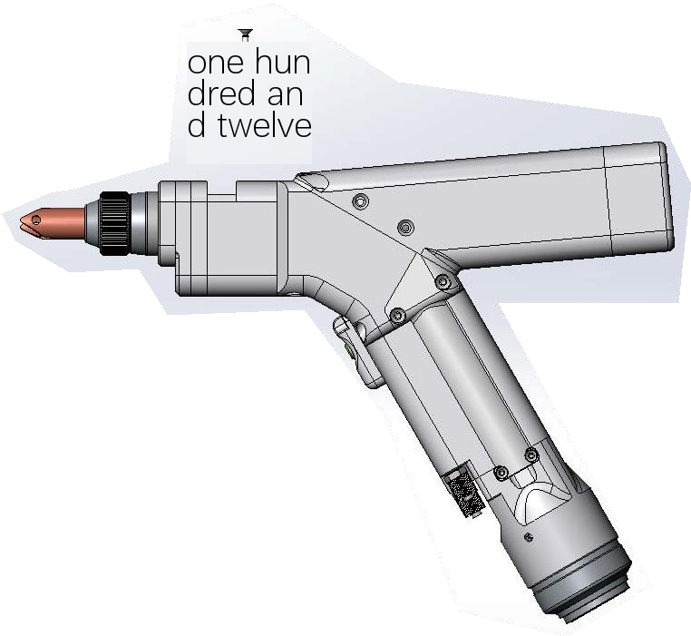
Locking screw
Metal ring clasp of lens

Protect the lens

Maintenance
For equipment maintenance, the machine must be shut down and the power supply must be cut off for 3 minutes before operation, otherwise there will be a risk of electric shock. When the ambient temperature is lower than 2 ℃, the internal water must be drained when the machine is stopped for a long time.
Dust prevention in summer In summer, please clean the condenser and dust screen of the equipment in about 15 days.
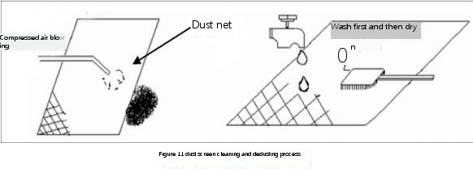
When the antifreezing equipment is transported in winter or not used for a long time, the water in the water tank should be drained through the drain valve, and the drain screw under the water pump should be loosened to drain the residual water in the water pump. If the ambient temperature at night is lower than 2 ℃, it is recommended that the customer does not stop the machine or add water.
The volume ratio of antifreeze and glycol shall be selected according to Table 1, and the freezing point to be prevented shall be equal to the ambient temperature of the equipment minus 5 ℃.
After the work is finished, the optical fiber shall be coiled up and put into the fixed position of the cabinet, and the welding gun shall be hung on the right side of the cabinet. Prevent trampling and breaking of optical fiber.
Break the head of the gun.
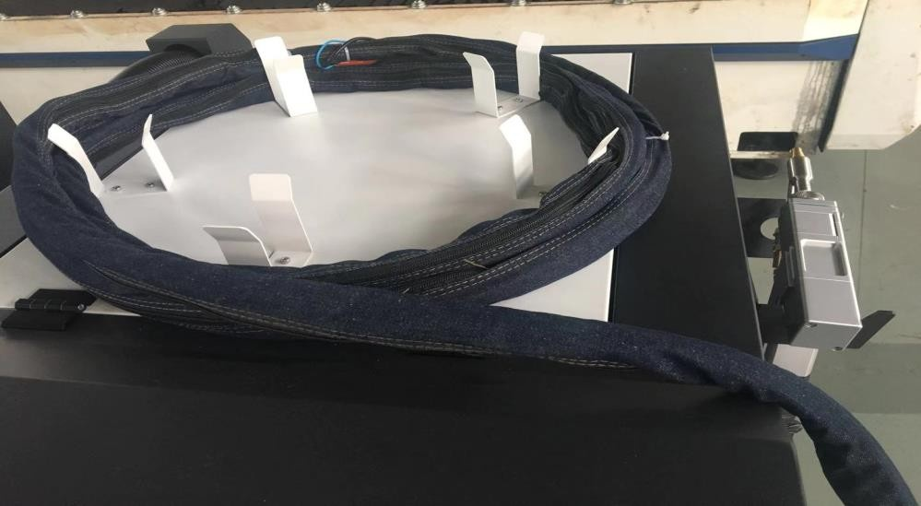
Left and right. When the average temperature of the day is higher than 5 ℃, replace the water containing antifreeze with demineralized water.

12

Process reference table
Check whether the red light is in the center before starting the machine every day.

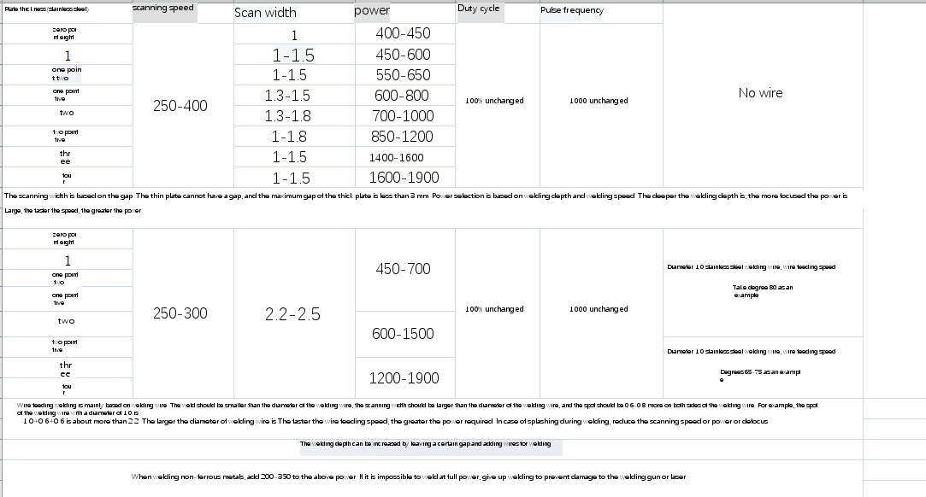

Fault and handling
Frequently asked questions | Fault description and solution
Laser alarm | - Check the water tank to see if it opens or alarms  - Whether the QBH (the connection between the optical fiber and the welding gun) is loose,
No light | - Check whether the laser is powered on and alarms.  - ① Normal, check whether the safety ground lock lamp is green, if it is gray, the safety ground lock is open circuit, and check the ground lock wire.  - ① ② Check whether the red light is normally emitted from the gun head. If there is red light but it cannot be emitted normally, there is a problem with the polarization of the swing mirror. At this time, the light cannot be emitted. Adjust the motor.  - ① ② ③ Normal, check the switch button, and there is no response when the switch is open.
The laser is getting weaker | - Check whether the protective lens is damaged and whether the protective gas is turned on.  - Check for welding at the focal point and reconfirm the focal point.  - Check whether the QBH is loose, which affects the change of focal length.  - If it is confirmed that the protective lens is normal and QBH is normal, check whether the focusing lens is damaged. Turn off the laser and shine the light on the inside of the gun head for observation.
Protective lenses are vulnerable | - Check whether the protective gas is opened and whether the gas pressure is sufficient.  - Avoid vertical welding or upward welding of the gun head.  - If the welding spatter is too large, select positive defocusing, low power, slow speed and low scanning speed.  - In the system setting interface, the time for gradual opening and closing of light is added.
Wire Feeder | - In case of manual wire feeding and automatic wire feeding, check whether the two-core wire feeding signal line is open circuit. The two-core wire feeding connector on the wire feeder can be short-circuited. After short-circuiting, the wire feeding signal line will be broken if the wire is fed normally.  - . Other non-wire feeding condition ? Check whether the wire feeder reels the wire and whether the wire feeding wheel is aligned with the corresponding welding wire.  Yes, whether the welding wire is too thin.  3. Wire feed speed cannot be changed or changed without change ? Contact after-sales personnel.
Water tank alarm | - Check whether the water pipe is bent and the waterway is blocked.  - Check whether there is no heat dissipation due to poor ventilation at the cabinet exhaust.  - The internal water channel is blocked due to the deterioration of water quality, or the cooling medium cannot be used due to the deterioration of water quality  Use.  - In winter and summer, the cooling water should be replaced in time, and it is not suitable for use in summer after filling antifreeze in winter.  - The alarm of the water tank has a code display, and the code docking problem water tank has a sign for comparison and confirmation.

