Wall System Installation Manual

I. Process Overview
This manual describes a hanging panel installation system. Fasteners are attached to the back of decorative wall panels, which are then hung onto wall-mounted components. The system features simple installation and allows for reversible disassembly and replacement. Panels are factory-processed as integrated units, ensuring higher precision and offering a wider selection of colors and sizes. Compared to traditional putty painting, this system is more environmentally friendly, resistant to dirt, and eliminates the risk of cracking over time.

II. Scope of Use
Applicable to interior wall finishing projects in industrial, civil, and public buildings, including hotels, hospitals, residential buildings, office spaces, etc.
1. For installation on rough base walls with poor flatness, use the T1 adjustable leveling hanging strip combined with M14 combination screws and T1 hangers to secure the wall panels.
2. For new walls with good flatness, use the T2 hanging strip combined with T1 hangers.
3. For new heavy-duty steel stud partition walls, use universal pins directly to install panels.
4. For areas requiring special shapes, custom special-shaped keels and components can be used to achieve the desired contours.

III. Accessory Names and Images
Order number | Picture | Name | Specifications
1 | 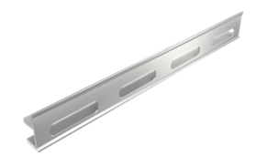 | Wall Hanging Strip T1 | 3 meters/piece
2 | 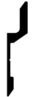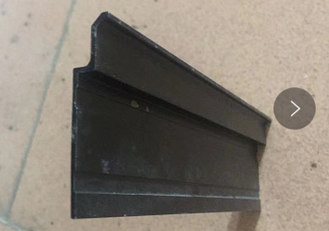 | Wall Hanging Strip T2 | 3 meters/piece
3 | 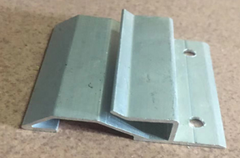 | Universal Pin
4 | 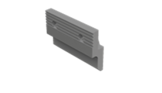 | T1 Hanger
5 | 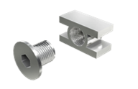 | M14 combination screw
6 | 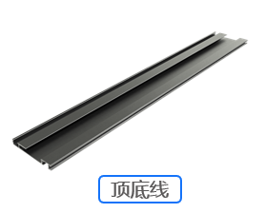 | T03 Top& Bottom Trim | 3 meters/piece
7 | 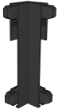 | Inside Corner Piece for T03 Trim
8 | 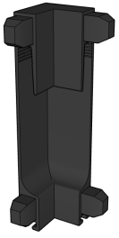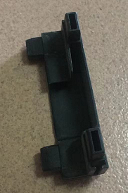 | Outside Corner Piece for T03 Trim
9 |  | Outside Corner Piece for T03 Trim
10 | 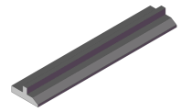 | T05 Micro-gap Strip | 3 meters/piece
11 | 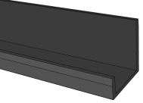 | T04-12 Edge Line | 3 meters/piece
12 |  | T08 Corner Line | 3 meters/piece
13 | 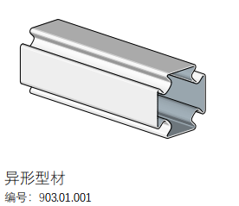 | Special-shaped Keel
14 | 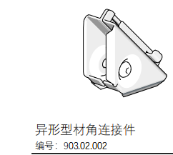 | Keel Connector
15 | 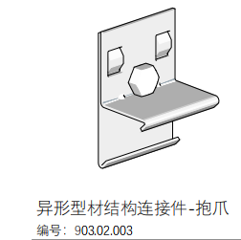 | Keel Connector – Clamp
16 | 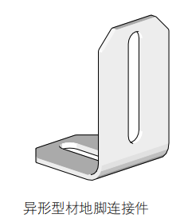 | Base Connector

IV. Installation Tools
- Impact drill with 6 mm drill bit
- Electric drill with screwdriver bits / triangle drill bits
- Aluminum cutting saw
- Oscillating saw
- Chalk line reel
- Step ladder
- Rubber mallet
- Laser level
- Air compressor and high-pressure nail gun
- Tape measure
- ST38 / ST25 steel nails
- Edge trimmer (router)
- Heavy-duty clamps
- Woodworking plane
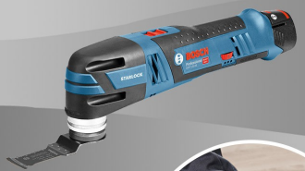

V. On-site Installation Prerequisites
- Partition wall keel installation has been completed and inspected.
- Concealed works (water pipes, electrical conduits, etc.) have been inspected and approved.
- Ceiling finishing work has been completed and inspected (aluminum honeycomb ceilings for kitchens and bathrooms to be installed after tiling).
- Flooring system and surface finishes have been installed and inspected.
VI. Installation Sequence
1. Snap chalk lines – The first line is marked 200 mm above the floor. Subsequent lines are marked at intervals not exceeding 600 mm. The top line position is determined as shown in the diagram.
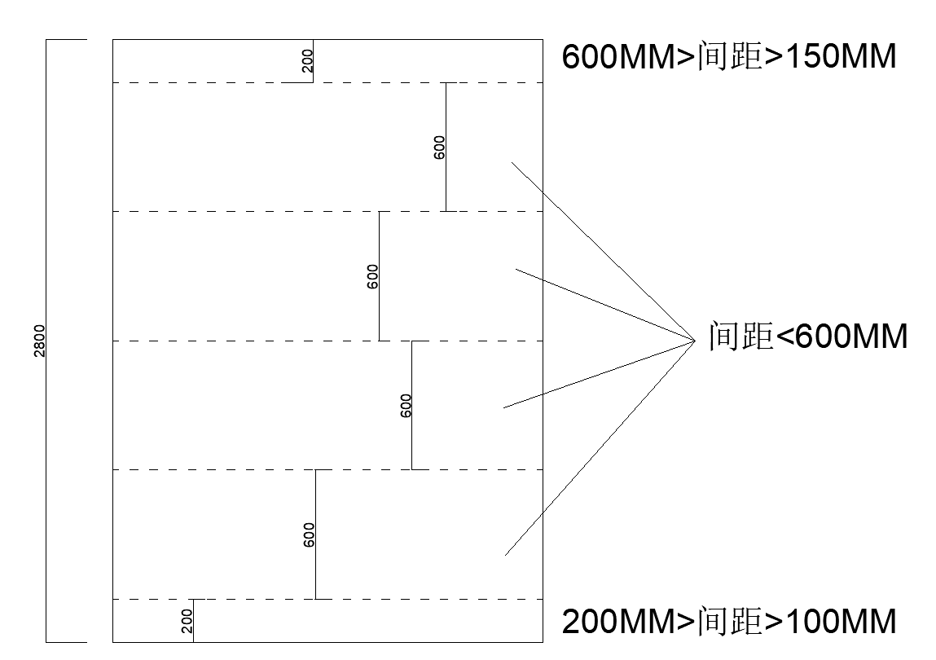
2. Install T03 top and bottom trims at the upper and lower edges of the wall.
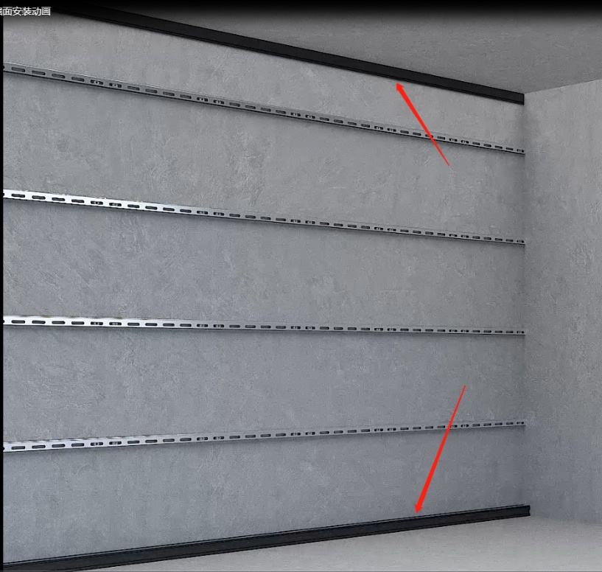

3. Install wall hanging strips:
A. For solid concrete walls: Insert the M14 combination screw into the pre-drilled hole on the T1 hanging strip. Align the bottom of the strip with the chalk line, mark the hole positions with a marker, then drill holes with an impact drill and insert expansion plugs.
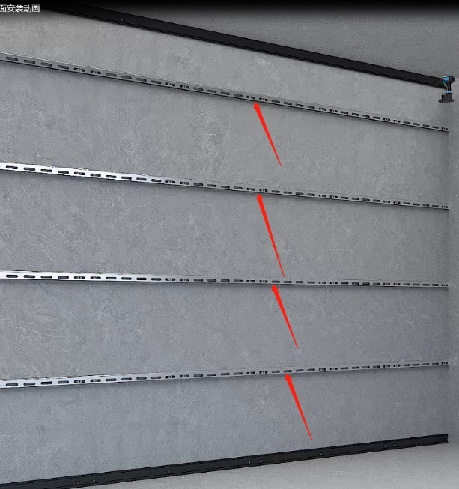
- For secondary masonry walls with good flatness: Use a nail gun to secure T2 hanging strips directly to the wall.
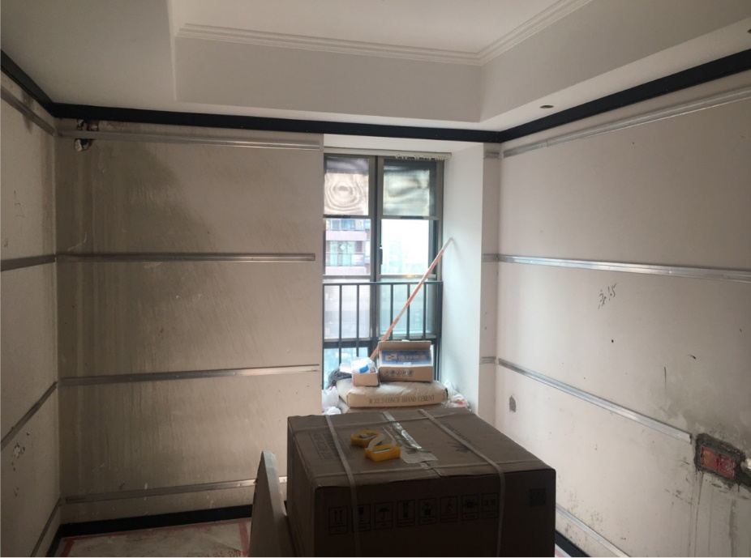
- For new fire-rated gypsum board partition walls with steel studs: After snapping chalk lines, align the keels accordingly and secure with screws using an electric drill.
4. Install all remaining hanging strips in the area. Place a 2-meter straightedge against them and use a hex wrench to adjust the leveling bolts. Secure the fixing screws on both ends first, then adjust the center screws. Verify the vertical flatness of all strips.
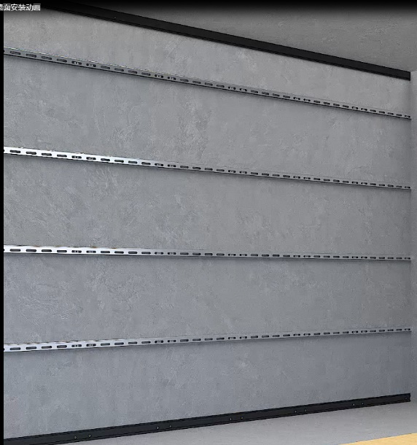

5. Prepare panels for hanging: On the ground (with protective film applied), place the board with its back side up. Mark the positions along the wall's fixed hanging strips, secure the mounting brackets with screws, ensuring they are approximately 50 mm from both sides of the board. For the first board installation, prioritize starting from an indoor corner (or a recessed corner if none is available).
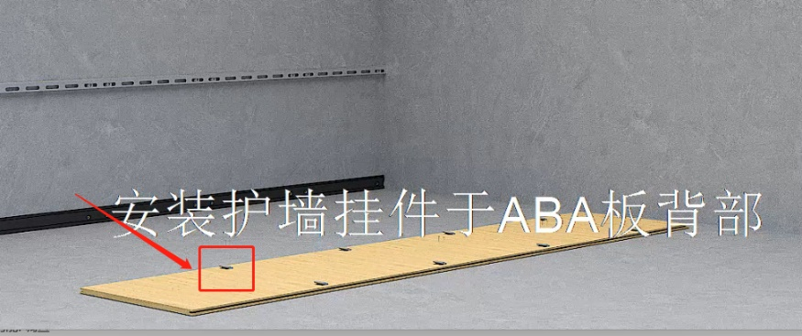
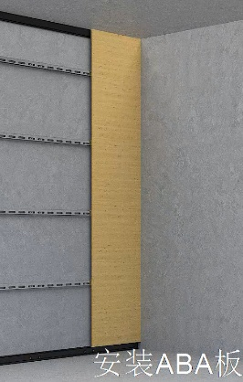

- Hang the first panel. Insert the right-angle edge of the T05 Micro-gap Strip into the tongue-and-groove joint of the panel. Tap gently with a rubber mallet to seat it firmly. Hang the next panel, slide it toward the micro-gap strip, align its groove with the strip, and insert the strip on the opposite side in the same manner. Do not tap the panel edge directly – always insert the micro-gap strip before tapping. Repeat this process for all panels. At internal corners, install edge trim as needed.
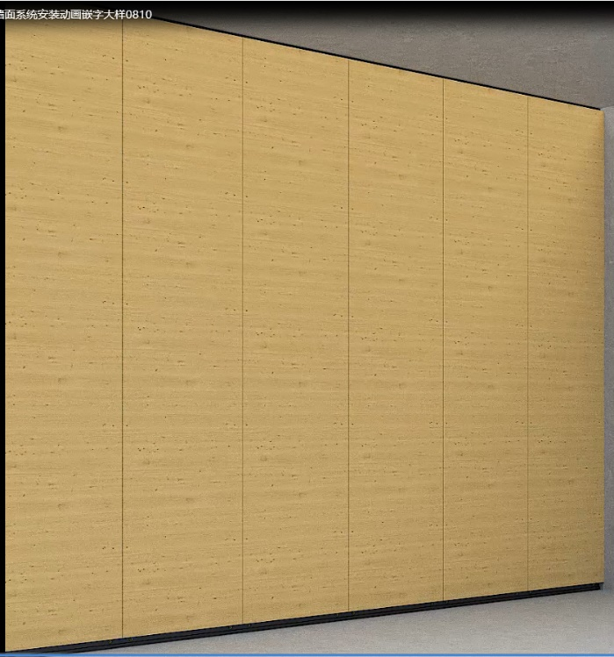
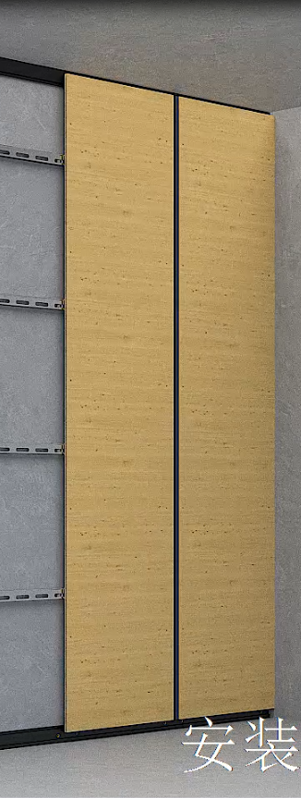
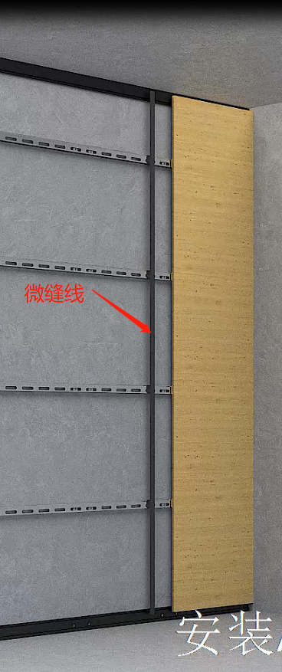
- Top and bottom sealing: Apply silicone sealant along the C-shaped trim and secure it to the top and bottom edges of the panels. At internal and external corners, the trim must be cut at 45° for 90° miter joints. See diagrams below for details on corner treatment and joint configurations:
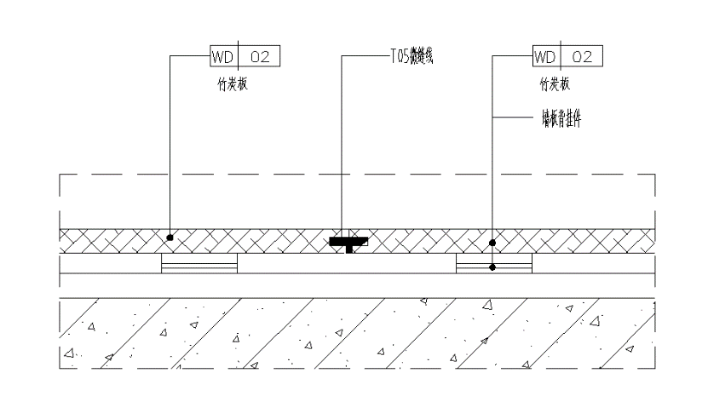
  - Natural joint
  - Metal strip joint with gap
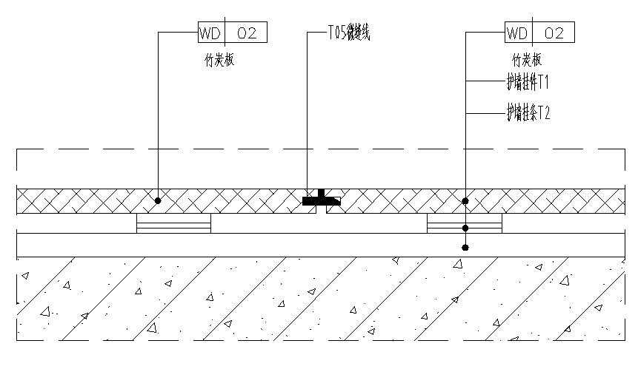
  - Internal corner finishing
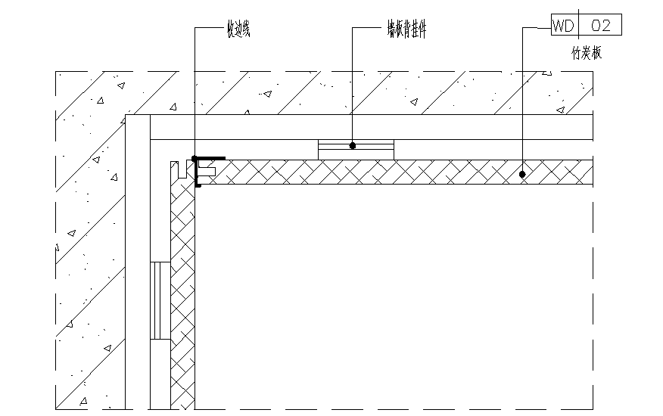
  - External corner finishing
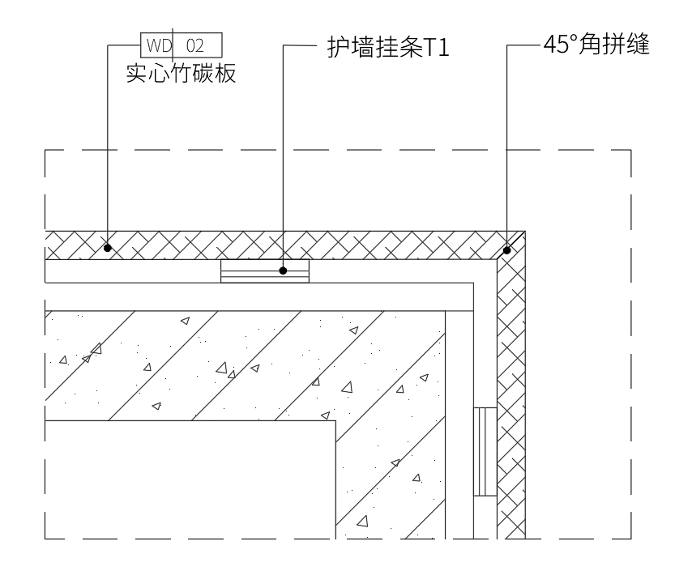
  - Curved external corner finishing (curved aluminum trim may be wrapped with film in the same color)
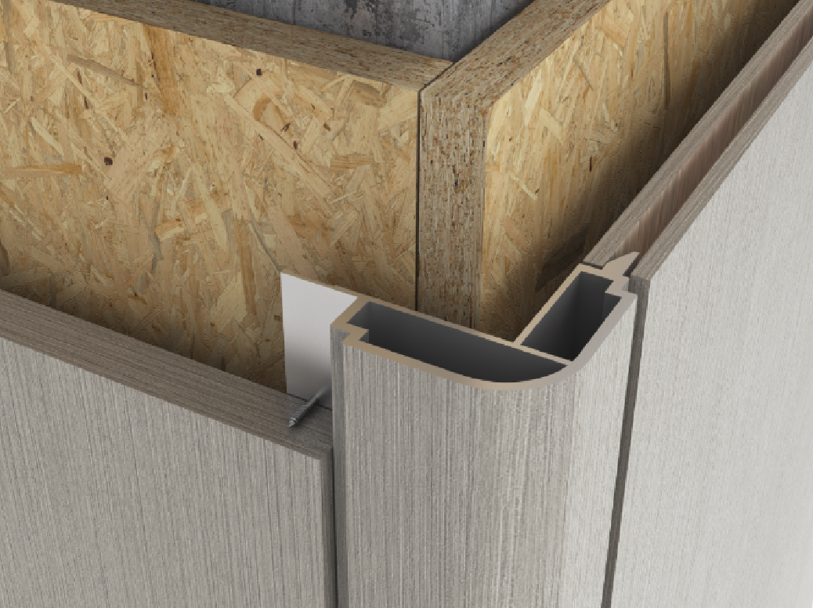

- During installation, mark all pre-installed electrical box positions on the panels and cut out openings using an oscillating saw. Do not miss any openings.
VII. Installation Details
1.T1 Leveling Keel Installation Detail
(Suitable for walls with poor flatness or uneven vertical/horizontal surfaces)
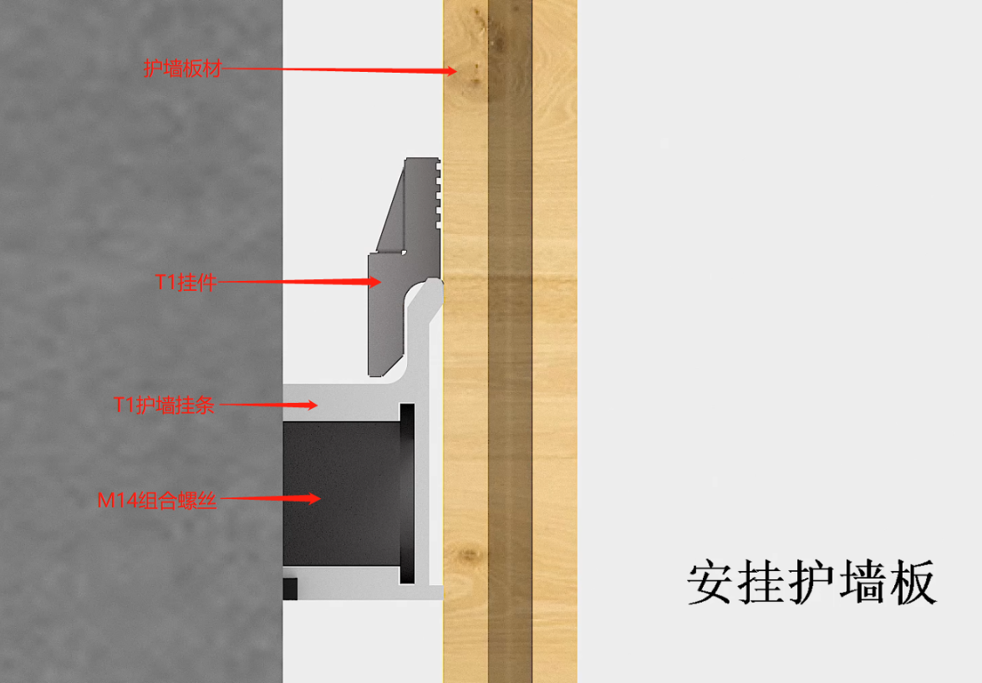
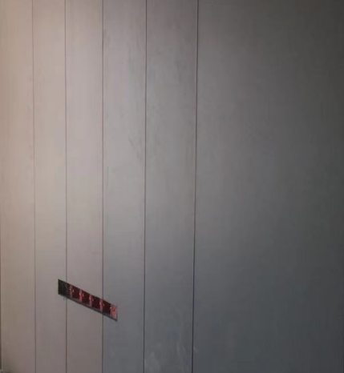
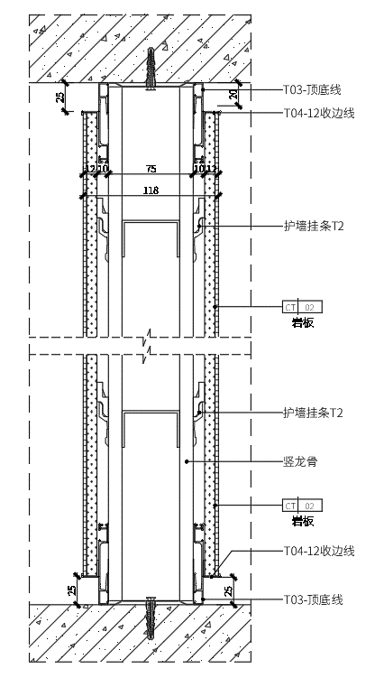
2. T2 Keel Installation Detail

3. Heavy-duty Steel Stud Partition Wall Detail
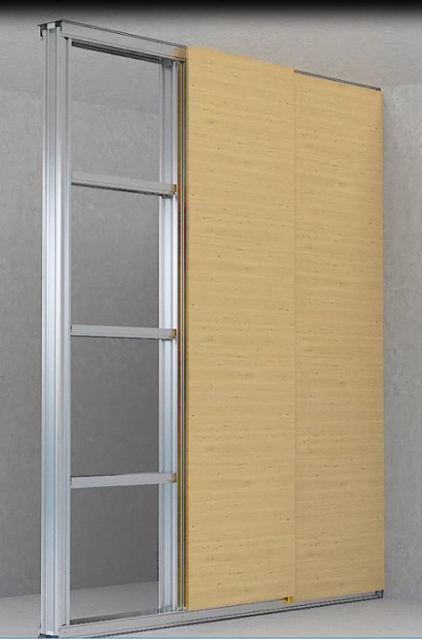
For heavy-duty partition walls, secure universal pins directly to the back of each panel with screws – T2 hanging strips are not required. Space the pins according to the spacing of the partition's horizontal members, then hang the panels using the same method described above.
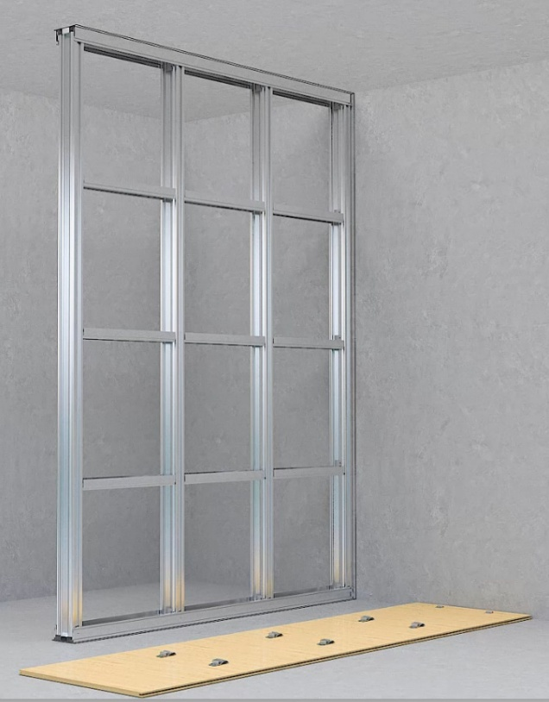
Construction detail diagram as below
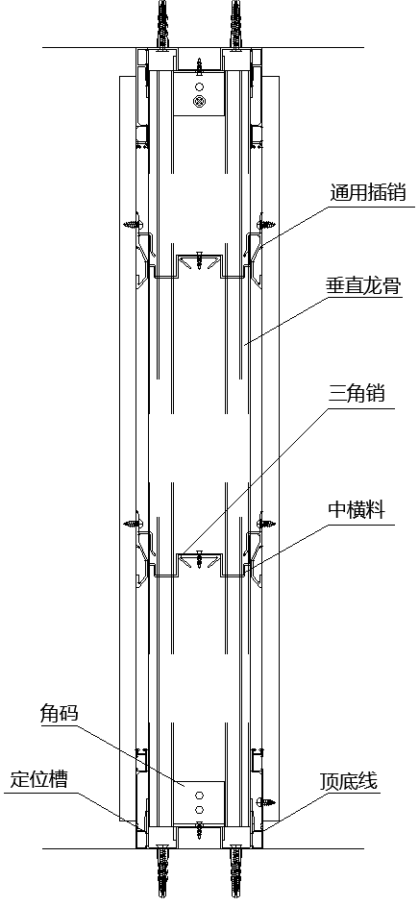

VIII. Acceptance Criteria
1. Appearance Quality
Panel surfaces shall be flat with neat edges and corners. The following defects are not acceptable: damage, corrugation, grooves, cracks, delamination, discoloration, chipped edges, or missing corners.
2. Allowable Tolerances and Inspection Methods
No. | Item | Allowable Deviation (mm) | Inspection Method
1 | Verticality of wall surface | 3 | 2m vertical straightedge
2 | Surface flatness | 3 | 2m straightedge and feeler gauge
3 | Corner squareness | 3 | Right-angle square
4 | Joint height difference | 1 | Steel ruler and feeler gauge
5 | Joint straightness | 2 | 5m chalk line (or pull line for shorter spans) + steel ruler
6 | Trim strip straightness | 2 | 5m chalk line (or pull line for shorter spans) + steel ruler

IX. V-Groove Cutting on Panel Backs (for Bending)
- Install the cutting tool on the edge trimmer with the blade exposed at 11 mm. Tool specifications are shown below and can be ordered online.
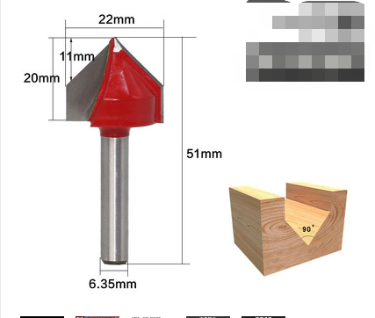
- Test on a scrap piece of panel. Cut V-grooves on the back surface, gradually increasing depth until the decorative film becomes visible but remains unbroken. Ensure the work surface is perfectly flat.
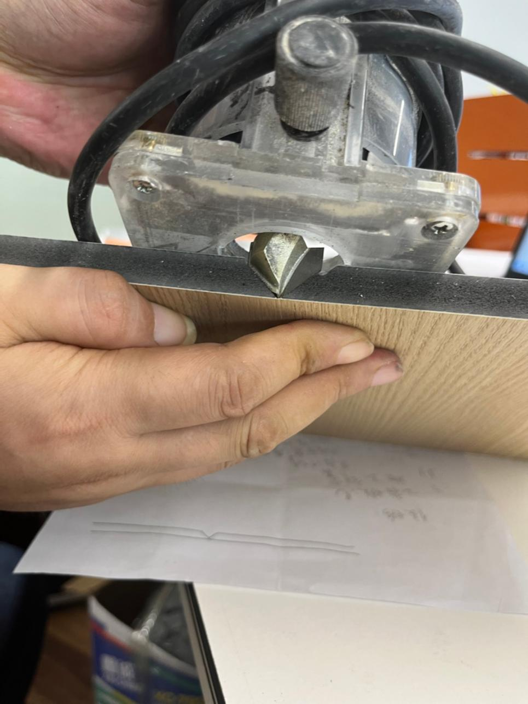
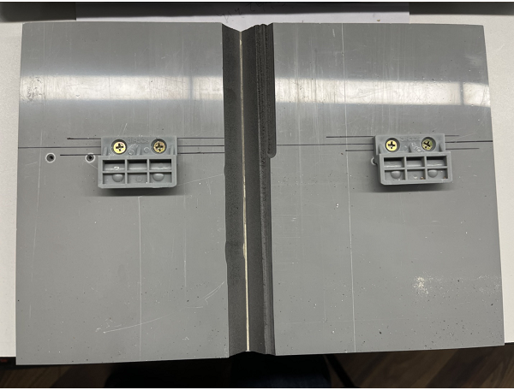
- Place the grooved panel at the corner position. Measure the distance L1 from the panel edge to the joint point. Mark both top and bottom edges on the back of the panel at the corresponding positions, then place the panel on a flat work surface.
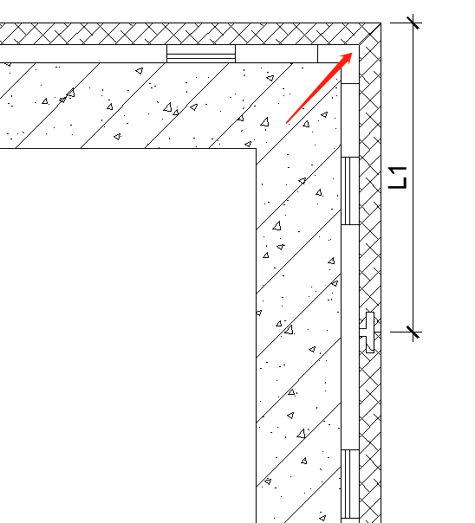
- Measure the edge guide offset of the trimmer and mark the cutting line accordingly.
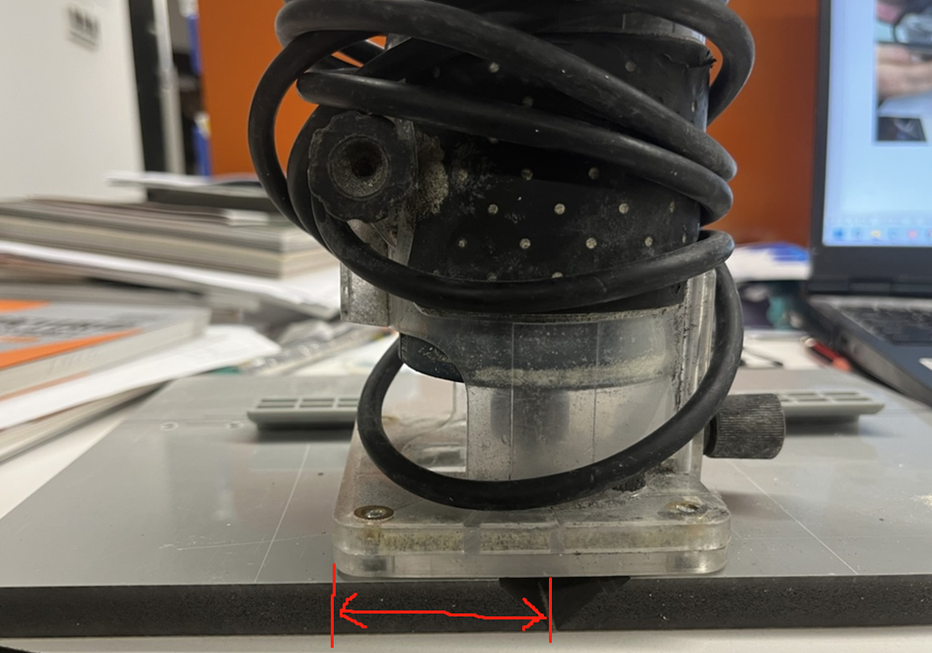
- Position a straightedge or a scrap piece with a straight edge along the marked guide line. Secure the panel with heavy-duty clamps. Use protective pads between the clamps and the panel surface to prevent damage. At the center, have an assistant stand on the straightedge to hold it firmly in place.
- After grooving, use a woodworking plane to lightly smooth the cut edges. This improves the corner fit when bending. To prevent film damage from repeated bending, fold the panel into position and apply super glue (e.g., 502) to secure the bend.
- Lift the panel to the installation position with two persons (one on each side), lower it into place, and use plastic shims and a rubber mallet to seat the joints securely.
- (Videos and additional images to be added)
X. Important Notes
- Select hanging components based on utility layout:
  - For concealed water/electrical pipes behind walls, use the T2 hanging strip system (thin-profile installation).
  - For exposed pipes on the wall surface, use the T1 hanging strip system with M14 combination screws.
  - For walls with good flatness or new light-gauge steel stud partitions, the T2 system is recommended for lower cost.
  - For rough walls with poor flatness, the T1 system is required.
- For mounting heavy items such as televisions or wall cabinets, install additional backing panels or reinforcing plates on the wall. If the exact mounting locations and load requirements are known in advance, pre-install anchor points in the wall structure to secure these items directly to the partition.

